UNITED STATES
SECURITIES AND EXCHANGE COMMISSION
Washington, D.C. 20549

FORM 8-K

CURRENT REPORT
PURSUANT TO SECTION 13 OR 15(d) OF THE SECURITIES EXCHANGE ACT OF 1934

Date of Report (Date of earliest event reported): October 20, 2026

UNITED COMMUNITY BANKS, INC.
(Exact name of registrant as specified in its charter)

Georgia | 001-35095 | 58-1807304
(State or other jurisdiction of incorporation) | (Commission file number) | (IRS Employer Identification No.)

200 East Camperdown Way
Greenville, South Carolina 29601
(Address of principal executive offices)

Registrant’s telephone number, including area code:
(800) 822-2651

Not applicable
(Former name or former address, if changed since last report)

Check the appropriate box below if the Form 8-K filing is intended to simultaneously satisfy the filing obligation of the registrant under any of the following provisions:

 | ☐ | Written communications pursuant to Rule 425 under the Securities Act (17 CFR 230.425)
 | ☐ | Soliciting material pursuant to Rule 14a-12 under the Exchange Act (17 CFR 240.14a-12)
 | ☐ | Pre-commencement communications pursuant to Rule 14d-2(b) under the Exchange Act (17 CFR 240.14d-2(b))
 | ☐ | Pre-commencement communications pursuant to Rule 13e-4(c) under the Exchange Act (17 CFR 240.13e-4(c))

Securities registered pursuant to Section 12(b) of the Act:

Title of Each Class |  | Trading Symbol(s) |  | Name of Each Exchange on Which Registered
Common stock, par value $1 per share |  | UCB |  | New York Stock Exchange

Indicate by check mark whether the registrant is an emerging growth company as defined in as defined in Rule 405 of the Securities Act of 1933 (§230.405 of this chapter) or Rule 12b-2 of the Securities Exchange Act of 1934 (§240.12b-2 of this chapter).

Emerging growth company ☐

If an emerging growth company, indicate by check mark if the registrant has elected not to use the extended transition period for complying with any new or revised financial accounting standards provided pursuant to Section 13(a) of the Exchange Act. ☐

 | Item 2.02 | Results of Operations and Financial Condition.

On October 20, 2026, United Community Banks, Inc. (“United Community”) issued a press release announcing financial results for its third fiscal quarter of 2026. The press release is furnished as Exhibit 99.1 to this Current Report on Form 8-K.

The information furnished pursuant to this Item 2.02, including Exhibit 99.1, shall not be deemed “filed” for purposes of Section 18 of the Securities Exchange Act of 1934 (the “Exchange Act”) or otherwise subject to the liabilities under Section 18 of the Exchange Act and shall not be deemed to be incorporated by reference into any filing of the Company under the Securities Act of 1933 or the Exchange Act.

 | Item 7.01 | Regulation FD Disclosure.

On October 20, 2026, United Community will hold an earnings conference call and webcast at 8:30 a.m. (Eastern Time) to discuss financial results for its third fiscal quarter of 2026. The press release referenced above in Item 2.02 contains information about how to access the conference call and webcast. A copy of the slide presentation to be used during the earnings call and webcast is furnished as Exhibit 99.2 to this Current Report on Form 8-K. The slide presentation also will be available on our website, www.ucbi.com, under the “Investor Relations – Events and Presentations” section.

The information furnished pursuant to this Item 7.01, including Exhibit 99.2, shall not be deemed “filed” for purposes of Section 18 of the Exchange Act or otherwise subject to the liabilities under Section 18 of the Exchange Act and shall not be deemed to be incorporated by reference into any filing of the Company under the Securities Act of 1933 or the Exchange Act.

 | Item 9.01 | Financial Statements and Exhibits.

(d) Exhibits

EXHIBIT INDEX

Exhibit No. |  | Description
99.1 |  | United Community Banks, Inc. Press Release, dated October 20, 2026.
99.2 |  | Slide presentation to be used during October 20, 2026 earnings call.
104 |  | The cover page from this Current Report on Form 8-K, formatted in Inline XBRL.

SIGNATURES

Pursuant to the requirements of the Securities Exchange Act of 1934, the registrant has duly caused this report to be signed on its behalf by the undersigned hereunto duly authorized.

 | UNITED COMMUNITY BANKS, INC.
 | By: | /s/ Tom Speir
 |  | Tom Speir
 |  | Executive Vice President and
 |  | Chief Financial Officer
Date: October 20, 2026

Exhibit 99.1



For Immediate Release

For more information:
Tom Speir
Chief Financial Officer
(864) 240-6208
Investor_Relations@ucbi.com

United Community Banks, Inc. Reports Third Quarter Earnings
Third Quarter Results Reflect Execution of Significant Strategic Initiatives, Strong Core Loan Growth, and Robust Deposit Growth

GREENVILLE, SC – October 20, 2026 – United Community Banks, Inc. (NYSE: UCB) (United) today announced financial results for the quarter ended September 30, 2026, which included 9.8% annualized core loan growth, 8.0% annualized core customer deposit growth, and a stable margin following six consecutive quarters of margin expansion.

Chairman and CEO Lynn Harton stated, “Our third quarter results reflect key strategic actions that simplify our balance sheet, reduce risk, and strengthen future operating performance. We completed the acquisition of Peach State Bank on August 1, the sale of our Navitas equipment finance business on September 1, and the restructuring of our investment portfolio in early September. The restructuring shortened duration and significantly improved the yield on our portfolio. At the same time, we achieved high single-digit growth in both core loans and customer deposits in the quarter, reflecting strong momentum resulting from our investment in hiring top talent. New loan production exceeded $1 billion for the second consecutive quarter. The strategies executed in the third quarter position us very well for the future, as demonstrated by improvements in operating return on assets, return on tangible common equity, and operating efficiency ratio.”

In the third quarter, United sold its Navitas equipment finance business for $2.0 billion in cash proceeds, a 7% premium to par. Following the sale, $2.2 billion in held-to-maturity securities were reclassified to available-for-sale designation and long-dated, low yielding securities with an amortized cost basis of $2.5 billion were subsequently sold. The securities repositioning resulted in $2.1 billion of cash proceeds, which, together with the $2.0 billion of Navitas sale proceeds, were redeployed into higher-yielding securities and used to pay down borrowings. Additionally, United completed the acquisition of Peach State Bancshares in the third quarter, increasing density in a dynamic growth market through a complementary, low-risk transaction.

Harton continued, “The actions completed in the third quarter allow us to focus on growing the core banking business within our outstanding Southeast footprint. We believe these actions, including our strong liquidity and capital, position us well for long-term success.”

Third Quarter 2026 Financial Highlights:

 | • | EPS of $(1.16) on a GAAP basis and $0.77 on an operating basis, compared to $0.95 and $0.71, respectively, in the second quarter of 2026. GAAP EPS reflects strategic actions executed in the third quarter to improve the long-term company performance, including the completion of the sale of our equipment finance business and repositioning of our investment securities portfolio.

 | • | Net loss of $139.7 million reflects strategic actions taken during the third quarter. Adjusting for those items, operating net income was $93.7 million in the third quarter, up 8% from the second quarter.
 | • | Total revenue of $(12.0) million resulted from the strategic actions taken in the third quarter. Adjusted for the gain from the sale of Navitas and the loss on the investment portfolio restructuring, which net to $304 million, total operating revenue was $292 million, up from $279 million in the second quarter.
 | • | Net interest margin of 3.68% increased by 10 basis points year-over-year and was stable from the second quarter of 2026.
 | • | Provision for credit losses totaled $10.0 million, including net charge-offs of $4.0 million, or 0.09% of loans for the third quarter.
 | o | Allowance for credit losses coverage was 1.05% of total loans, up one basis point from June 30, 2026.
 | • | Noninterest expense increased $2.3 million on a GAAP basis and decreased $3.3 million on an operating basis, compared to the second quarter.
 | • | Third quarter income taxes reflect the specific tax rates applicable to the Navitas sale and investment securities losses, as well as a higher core effective tax rate resulting from higher estimated pre-tax income and certain discrete items recognized in the quarter.
 | • | GAAP efficiency ratio is not meaningful due to the securities losses incurred in the third quarter. Operating efficiency ratio improved to 53.1% from 56.7% in the second quarter.
 | • | Loan growth of $444 million, or 9.8% annualized, from the second quarter, excluding the impact of Peach State and Navitas.
 | • | Customer deposits were up $473 million, or 8.0% annualized, from the second quarter, excluding deposits received from the Peach State acquisition.
 | • | Peach State contributed $520 million of loans and $678 million of deposits at the time of the acquisition.
 | • | Return on assets was (1.89%) on a GAAP basis and 1.27% on an operating basis. Operating return on assets improved 5 bps from the second quarter.
 | • | Return on common equity on a GAAP basis and return on tangible common equity on an operating basis were (14.8%) and 13.9%, respectively.
 | • | Repurchased 1.395 million common shares at an average price of $35.81 per share for an aggregate of $50 million in the third quarter. The Board also approved an incremental $100 million share repurchase authorization through the end of 2027, bringing the current outstanding repurchase authorization to $113 million.
 | • | Maintained strong capital ratios with preliminary Common Equity Tier 1 of 13.0%.
 | • | Quarterly common dividend increased to $0.26 per share declared during the quarter, up 4% year over year.

Year to Date 2026 Financial Highlights:

 | • | Net income of $60.2 million, lowered by strategic actions taken in the third quarter. Net income – operating of $265 million, compared with $249 million in 2025.
 | • | Diluted earnings per share of $0.49, or $2.18 on an operating basis compared with operating earnings per share of $2.00 in 2025.
 | • | Total revenue of $544 million, or $843 million on an operating basis, up 7% from 2025.
 | • | Return on assets of 0.28%, or 1.24% on an operating basis up from 1.19% operating return on assets for 2025.
 | • | Pre-tax, pre-provision return on assets of 1.76% on an operating basis up from 1.70% operating pre-tax, pre-provision return on assets for 2025.

 | • | Return on common equity of 2.18%, or 9.58% on an operating basis compared with 8.92% operating return on common equity for 2025.
 | • | Operating return on tangible common equity of 13.3%, up from 12.6% for 2025.

Additional details about the previously announced strategic actions taken in the third quarter are available under “Events and Presentations” in the “News and Events” section of the Investor Relations page on the company's website, ucbi.com, or directly at https://ir.ucbi.com/events/event-details/strategic-initiatives-conference-call.

Conference Call

United will hold a conference call on Tuesday, October 20, 2026 at 8:30 a.m. ET to discuss the contents of this press release and to share business highlights for the quarter. Participants can pre-register for the conference call by navigating to https://dpregister.com/sreg/10209322/1040c6adc70. Those without internet access or unable to pre-register may dial in by calling 1-844-676-1337. The conference call also will be webcast and may be accessed by selecting “Events and Presentations” under “News and Events” within the Investor Relations section of the company's website, ucbi.com.

UNITED COMMUNITY BANKS, INC.
Selected Financial Information
(in thousands, except per share data)

 |  | 2026 |  |  |  |  |  |  |  | 2025 |  |  |  |  |  |  |  |  |  |  |  | Third  Quarter  2026- |  |  |  | For the Nine Months Ended  September 30, |  |  |  |  |  |  |  | YTD  2026 -
 |  | Third  Quarter |  |  |  | Second  Quarter |  |  |  | First  Quarter |  |  |  | Fourth  Quarter |  |  |  | Third  Quarter |  |  |  | 2025  Change |  |  |  | 2026 |  |  |  | 2025 |  |  |  | 2025  Change
INCOME SUMMARY
Interest revenue |  | $ | 362,560 |  |  | $ | 344,371 |  |  | $ | 333,961 |  |  | $ | 346,367 |  |  | $ | 353,850 |  |  |  |  |  |  | $ | 1,040,892 |  |  | $ | 1,036,572
Interest expense |  |  | 111,354 |  |  |  | 103,471 |  |  |  | 101,197 |  |  |  | 108,441 |  |  |  | 120,221 |  |  |  |  |  |  |  | 316,022 |  |  |  | 365,391
Net interest revenue |  |  | 251,206 |  |  |  | 240,900 |  |  |  | 232,764 |  |  |  | 237,926 |  |  |  | 233,629 |  |  |  | 8 | % |  |  | 724,870 |  |  |  | 671,181 |  |  |  | 8 | %
Noninterest income |  |  | (263,172 | ) |  |  | 38,380 |  |  |  | 43,746 |  |  |  | 40,462 |  |  |  | 43,219 |  |  |  | n/m |  |  |  | (181,046 | ) |  |  | 113,583 |  |  |  | n/m
Total revenue |  |  | (11,966 | ) |  |  | 279,280 |  |  |  | 276,510 |  |  |  | 278,388 |  |  |  | 276,848 |  |  |  | n/m |  |  |  | 543,824 |  |  |  | 784,764 |  |  |  | (31 | )
Provision for credit losses |  |  | 10,013 |  |  |  | (29,803 | ) |  |  | 10,853 |  |  |  | 13,662 |  |  |  | 7,907 |  |  |  | n/m |  |  |  | (8,937 | ) |  |  | 35,144 |  |  |  | n/m
Noninterest expense |  |  | 162,241 |  |  |  | 159,915 |  |  |  | 157,302 |  |  |  | 152,048 |  |  |  | 150,868 |  |  |  | 8 |  |  |  | 479,458 |  |  |  | 439,886 |  |  |  | 9
Income (loss) before income tax expense |  |  | (184,220 | ) |  |  | 149,168 |  |  |  | 108,355 |  |  |  | 112,678 |  |  |  | 118,073 |  |  |  | n/m |  |  |  | 73,303 |  |  |  | 309,734 |  |  |  | (76 | )
Income tax (benefit) expense |  |  | (44,475 | ) |  |  | 33,530 |  |  |  | 24,066 |  |  |  | 26,223 |  |  |  | 26,579 |  |  |  | n/m |  |  |  | 13,121 |  |  |  | 68,094 |  |  |  | (81 | )
Net (loss) income |  |  | (139,745 | ) |  |  | 115,638 |  |  |  | 84,289 |  |  |  | 86,455 |  |  |  | 91,494 |  |  |  | n/m |  |  |  | 60,182 |  |  |  | 241,640 |  |  |  | (75 | )
Non-operating items |  |  | 310,380 |  |  |  | (37,582 | ) |  |  | 508 |  |  |  | 606 |  |  |  | 3,468 |  |  |  |  |  |  |  | 273,306 |  |  |  | 9,598
Income tax related to non-operating items |  |  | (76,932 | ) |  |  | 8,347 |  |  |  | (113 | ) |  |  | (133 | ) |  |  | (751 | ) |  |  |  |  |  |  | (68,698 | ) |  |  | (2,079 | )
Net income - operating (1) |  | $ | 93,703 |  |  | $ | 86,403 |  |  | $ | 84,684 |  |  | $ | 86,928 |  |  | $ | 94,211 |  |  |  | (1 | ) |  | $ | 264,790 |  |  | $ | 249,159 |  |  |  | 6
Pre-tax pre-provision income (5) |  | $ | (174,207 | ) |  | $ | 119,365 |  |  | $ | 119,208 |  |  | $ | 126,340 |  |  | $ | 125,980 |  |  |  | n/m |  |  | $ | 64,366 |  |  | $ | 344,878 |  |  |  | (81 | )
PERFORMANCE MEASURES
Per common share:
Diluted net income - GAAP |  | $ | (1.16 | ) |  | $ | 0.95 |  |  | $ | 0.69 |  |  | $ | 0.70 |  |  | $ | 0.70 |  |  |  | n/m |  |  | $ | 0.49 |  |  | $ | 1.91 |  |  |  | (74 | )
Diluted net income - operating (1) |  |  | 0.77 |  |  |  | 0.71 |  |  |  | 0.70 |  |  |  | 0.71 |  |  |  | 0.75 |  |  |  | 3 |  |  |  | 2.18 |  |  |  | 2.00 |  |  |  | 9
Cash dividends declared |  |  | 0.26 |  |  |  | 0.25 |  |  |  | 0.25 |  |  |  | 0.25 |  |  |  | 0.25 |  |  |  | 4 |  |  |  | 0.76 |  |  |  | 0.73 |  |  |  | 4
Book value |  |  | 29.27 |  |  |  | 31.27 |  |  |  | 30.54 |  |  |  | 30.17 |  |  |  | 29.44 |  |  |  | (1 | ) |  |  | 29.27 |  |  |  | 29.44 |  |  |  | (1 | )
Tangible book value (3) |  |  | 20.80 |  |  |  | 23.31 |  |  |  | 22.56 |  |  |  | 22.24 |  |  |  | 21.59 |  |  |  | (4 | ) |  |  | 20.80 |  |  |  | 21.59 |  |  |  | (4 | )
Key performance ratios:
Return on common equity - GAAP (2)(4) |  |  | (14.85 | )% |  |  | 12.56 | % |  |  | 9.35 | % |  |  | 9.48 | % |  |  | 9.20 | % |  |  |  |  |  |  | 2.18 | % |  |  | 8.53 | %
Return on common equity - operating (1)(2)(4) |  |  | 9.95 |  |  |  | 9.39 |  |  |  | 9.39 |  |  |  | 9.53 |  |  |  | 9.83 |  |  |  |  |  |  |  | 9.58 |  |  |  | 8.92
Return on tangible common equity - operating (1)(2)(3)(4) |  |  | 13.90 |  |  |  | 12.98 |  |  |  | 13.05 |  |  |  | 13.31 |  |  |  | 13.56 |  |  |  |  |  |  |  | 13.32 |  |  |  | 12.57
Return on assets - GAAP (4) |  |  | (1.89 | ) |  |  | 1.63 |  |  |  | 1.22 |  |  |  | 1.21 |  |  |  | 1.29 |  |  |  |  |  |  |  | 0.28 |  |  |  | 1.16
Return on assets - operating (1)(4) |  |  | 1.27 |  |  |  | 1.22 |  |  |  | 1.22 |  |  |  | 1.22 |  |  |  | 1.33 |  |  |  |  |  |  |  | 1.24 |  |  |  | 1.19
Return on assets - pre-tax pre-provision, excluding non-operating items(1)(4)(5) |  |  | 1.84 |  |  |  | 1.70 |  |  |  | 1.73 |  |  |  | 1.78 |  |  |  | 1.83 |  |  |  |  |  |  |  | 1.76 |  |  |  | 1.70
Net interest margin (fully taxable equivalent) (4) |  |  | 3.68 |  |  |  | 3.68 |  |  |  | 3.65 |  |  |  | 3.62 |  |  |  | 3.58 |  |  |  |  |  |  |  | 3.67 |  |  |  | 3.48
Efficiency ratio - GAAP |  |  | n/m |  |  |  | 57.01 |  |  |  | 56.66 |  |  |  | 54.40 |  |  |  | 54.30 |  |  |  |  |  |  |  | 87.58 |  |  |  | 55.86
Efficiency ratio - operating (1) |  |  | 53.11 |  |  |  | 56.69 |  |  |  | 55.65 |  |  |  | 54.19 |  |  |  | 53.05 |  |  |  |  |  |  |  | 55.12 |  |  |  | 54.64
Equity to total assets |  |  | 12.14 |  |  |  | 12.89 |  |  |  | 12.97 |  |  |  | 12.99 |  |  |  | 12.78 |  |  |  |  |  |  |  | 12.14 |  |  |  | 12.78
Tangible common equity to tangible assets (3) |  |  | 8.95 |  |  |  | 9.94 |  |  |  | 9.92 |  |  |  | 9.92 |  |  |  | 9.71 |  |  |  |  |  |  |  | 8.95 |  |  |  | 9.71
ASSET QUALITY
Nonperforming assets ("NPAs") |  | $ | 81,270 |  |  | $ | 103,387 |  |  | $ | 98,623 |  |  | $ | 93,498 |  |  | $ | 97,916 |  |  |  | (17 | ) |  | $ | 81,270 |  |  | $ | 97,916 |  |  |  | (17 | )
ACL - funded loans |  |  | 179,143 |  |  |  | 168,705 |  |  |  | 208,396 |  |  |  | 210,429 |  |  |  | 215,791 |  |  |  | (17 | ) |  |  | 179,143 |  |  |  | 215,791 |  |  |  | (17 | )
ACL - total |  |  | 200,237 |  |  |  | 188,329 |  |  |  | 225,996 |  |  |  | 225,520 |  |  |  | 228,276 |  |  |  | (12 | ) |  |  | 200,237 |  |  |  | 228,276 |  |  |  | (12 | )
Net charge-offs |  |  | 3,973 |  |  |  | 7,864 |  |  |  | 10,377 |  |  |  | 16,418 |  |  |  | 7,676 |  |  |  | (48 | ) |  |  | 22,214 |  |  |  | 25,508 |  |  |  | (13 | )
ACL - funded loans to loans |  |  | 0.94 | % |  |  | 0.94 | % |  |  | 1.06 | % |  |  | 1.09 | % |  |  | 1.13 | % |  |  |  |  |  |  | 0.94 | % |  |  | 1.13 | %
ACL - total to loans |  |  | 1.05 |  |  |  | 1.04 |  |  |  | 1.15 |  |  |  | 1.16 |  |  |  | 1.19 |  |  |  |  |  |  |  | 1.05 |  |  |  | 1.19
Net charge-offs to average loans HFI (4) |  |  | 0.09 |  |  |  | 0.16 |  |  |  | 0.22 |  |  |  | 0.34 |  |  |  | 0.16 |  |  |  |  |  |  |  | 0.15 |  |  |  | 0.18
NPAs to total assets |  |  | 0.28 |  |  |  | 0.36 |  |  |  | 0.35 |  |  |  | 0.33 |  |  |  | 0.35 |  |  |  |  |  |  |  | 0.28 |  |  |  | 0.35
AT PERIOD END ($ in millions)
Loans held for investment |  | $ | 18,988 |  |  | $ | 18,024 |  |  | $ | 19,602 |  |  | $ | 19,384 |  |  | $ | 19,175 |  |  |  | (1 | ) |  | $ | 18,988 |  |  | $ | 19,175 |  |  |  | (1 | )
Investment securities |  |  | 6,641 |  |  |  | 6,377 |  |  |  | 5,889 |  |  |  | 5,988 |  |  |  | 6,163 |  |  |  | 8 |  |  |  | 6,641 |  |  |  | 6,163 |  |  |  | 8
Total assets |  |  | 28,882 |  |  |  | 29,051 |  |  |  | 28,177 |  |  |  | 28,003 |  |  |  | 28,143 |  |  |  | 3 |  |  |  | 28,882 |  |  |  | 28,143 |  |  |  | 3
Deposits |  |  | 24,888 |  |  |  | 23,724 |  |  |  | 24,025 |  |  |  | 23,798 |  |  |  | 24,021 |  |  |  | 4 |  |  |  | 24,888 |  |  |  | 24,021 |  |  |  | 4
Shareholders’ equity |  |  | 3,507 |  |  |  | 3,745 |  |  |  | 3,655 |  |  |  | 3,639 |  |  |  | 3,597 |  |  |  | (3 | ) |  |  | 3,507 |  |  |  | 3,597 |  |  |  | (3 | )
Common shares outstanding (thousands) |  |  | 119,827 |  |  |  | 119,764 |  |  |  | 119,684 |  |  |  | 120,598 |  |  |  | 121,553 |  |  |  | (1 | ) |  |  | 119,827 |  |  |  | 121,553 |  |  |  | (1 | )

(1) Excludes non-operating items as detailed on Non-GAAP Performance Measures Reconciliation. (2) Net income less preferred stock dividends, divided by average common equity. (3) Excludes effect of acquisition related intangibles and associated amortization. (4) Annualized. (5) Excludes income tax expense and provision for credit losses.

UNITED COMMUNITY BANKS, INC.
Loan Portfolio Composition at Period-End

 |  | 2026 |  |  |  |  |  |  |  |  |  |  |  | 2025 |  |  |  |  |  |  |  | Linked |  |  |  | Year over
(in millions) |  | Third  Quarter |  |  |  | Second  Quarter |  |  |  | First  Quarter |  |  |  | Fourth  Quarter |  |  |  | Third  Quarter |  |  |  | Quarter  Change |  |  |  | Year  Change
LOANS BY CATEGORY
Owner occupied commercial RE |  | $ | 4,336 |  |  | $ | 4,117 |  |  | $ | 4,041 |  |  | $ | 3,950 |  |  | $ | 3,678 |  |  | $ | 219 |  |  | $ | 658
Income producing commercial RE |  |  | 5,217 |  |  |  | 5,018 |  |  |  | 4,984 |  |  |  | 5,032 |  |  |  | 4,534 |  |  |  | 199 |  |  |  | 683
Commercial & industrial (1) |  |  | 2,976 |  |  |  | 2,859 |  |  |  | 2,771 |  |  |  | 2,696 |  |  |  | 2,593 |  |  |  | 117 |  |  |  | 383
Commercial construction & land |  |  | 1,360 |  |  |  | 1,143 |  |  |  | 1,072 |  |  |  | 998 |  |  |  | 1,734 |  |  |  | 217 |  |  |  | (374 | )
Equipment financing (1) |  |  | — |  |  |  | — |  |  |  | 1,897 |  |  |  | 1,848 |  |  |  | 1,808 |  |  |  | — |  |  |  | (1,808 | )
Total commercial |  |  | 13,889 |  |  |  | 13,137 |  |  |  | 14,765 |  |  |  | 14,524 |  |  |  | 14,347 |  |  |  | 752 |  |  |  | (458 | )
Residential mortgage |  |  | 3,198 |  |  |  | 3,101 |  |  |  | 3,122 |  |  |  | 3,157 |  |  |  | 3,198 |  |  |  | 97 |  |  |  | —
Home equity |  |  | 1,504 |  |  |  | 1,403 |  |  |  | 1,344 |  |  |  | 1,319 |  |  |  | 1,252 |  |  |  | 101 |  |  |  | 252
Residential construction & land |  |  | 211 |  |  |  | 195 |  |  |  | 185 |  |  |  | 191 |  |  |  | 178 |  |  |  | 16 |  |  |  | 33
Consumer |  |  | 195 |  |  |  | 193 |  |  |  | 187 |  |  |  | 188 |  |  |  | 192 |  |  |  | 2 |  |  |  | 3
Other |  |  | (9 | ) |  |  | (5 | ) |  |  | (1 | ) |  |  | 5 |  |  |  | 8 |  |  |  | (4 | ) |  |  | (17 | )
Total loans held for investment |  | $ | 18,988 |  |  | $ | 18,024 |  |  | $ | 19,602 |  |  | $ | 19,384 |  |  | $ | 19,175 |  |  | $ | 964 |  |  | $ | (187 | )
LOANS BY MARKET
Georgia |  | $ | 5,336 |  |  | $ | 4,662 |  |  | $ | 4,617 |  |  | $ | 4,635 |  |  | $ | 4,584 |  |  | $ | 674 |  |  | $ | 752
South Carolina |  |  | 3,180 |  |  |  | 3,130 |  |  |  | 3,037 |  |  |  | 2,971 |  |  |  | 2,926 |  |  |  | 50 |  |  |  | 254
North Carolina |  |  | 2,786 |  |  |  | 2,706 |  |  |  | 2,722 |  |  |  | 2,712 |  |  |  | 2,676 |  |  |  | 80 |  |  |  | 110
Tennessee |  |  | 1,979 |  |  |  | 1,962 |  |  |  | 1,895 |  |  |  | 1,913 |  |  |  | 1,902 |  |  |  | 17 |  |  |  | 77
Florida |  |  | 3,398 |  |  |  | 3,283 |  |  |  | 3,229 |  |  |  | 3,102 |  |  |  | 3,040 |  |  |  | 115 |  |  |  | 358
Alabama |  |  | 1,114 |  |  |  | 1,082 |  |  |  | 1,049 |  |  |  | 1,050 |  |  |  | 1,054 |  |  |  | 32 |  |  |  | 60
Commercial Banking Solutions (2) |  |  | 1,195 |  |  |  | 1,199 |  |  |  | 3,053 |  |  |  | 3,001 |  |  |  | 2,993 |  |  |  | (4 | ) |  |  | (1,798 | )
Total loans held for investment |  | $ | 18,988 |  |  | $ | 18,024 |  |  | $ | 19,602 |  |  | $ | 19,384 |  |  | $ | 19,175 |  |  | $ | 964 |  |  | $ | (187 | )

(1) Substantially all equipment financing loans were transferred to held for sale in the second quarter of 2026 as a result of the then-pending sale of Navitas Credit Corp, which subsequently closed on September 1, 2026. Retained equipment financing loans were reclassified to the commercial & industrial line.
(2) Reduction in the second quarter of 2026 reflects the transfer of substantially all equipment financing loans to held for sale.

UNITED COMMUNITY BANKS, INC.
Credit Quality
(in thousands)

 |  | 2026
 |  | Third  Quarter |  |  |  | Second  Quarter |  |  |  | First  Quarter
NONACCRUAL LOANS
Owner occupied RE |  | $ | 12,002 |  |  | $ | 20,027 |  |  | $ | 18,265
Income producing RE |  |  | 10,880 |  |  |  | 11,655 |  |  |  | 11,037
Commercial & industrial |  |  | 16,585 |  |  |  | 21,147 |  |  |  | 19,890
Commercial construction & land |  |  | 106 |  |  |  | 916 |  |  |  | 17
Equipment financing (1) |  |  | — |  |  |  | — |  |  |  | 8,024
Total commercial |  |  | 39,573 |  |  |  | 53,745 |  |  |  | 57,233
Residential mortgage |  |  | 31,444 |  |  |  | 30,506 |  |  |  | 31,906
Home equity |  |  | 6,060 |  |  |  | 6,435 |  |  |  | 6,209
Residential construction & land |  |  | 281 |  |  |  | 338 |  |  |  | 355
Consumer |  |  | 962 |  |  |  | 977 |  |  |  | 1,009
Total nonaccrual loans held for investment |  |  | 78,320 |  |  |  | 92,001 |  |  |  | 96,712
Equipment finance nonaccrual loans held for sale (1) |  |  | — |  |  |  | 9,392 |  |  |  | —
OREO and repossessed assets |  |  | 2,950 |  |  |  | 1,994 |  |  |  | 1,911
Total NPAs |  | $ | 81,270 |  |  | $ | 103,387 |  |  | $ | 98,623

(1) Substantially all equipment financing loans were transferred to held for sale in the second quarter of 2026 and were subsequently sold in the sale of Navitas Credit Corp. on September 1, 2026. Retained equipment financing loans were reclassified to the commercial & industrial loan category, as equipment financing is no longer an individually significant loan category.

 |  | 2026
 |  | Third Quarter |  |  |  |  |  |  |  | Second Quarter |  |  |  |  |  |  |  | First Quarter
(in thousands) |  | Net Charge-  Offs |  |  |  | Net Charge-  Offs to  Average  Loans (1) |  |  |  | Net Charge-  Offs |  |  |  | Net Charge-  Offs to  Average  Loans (1) |  |  |  | Net Charge-  Offs |  |  |  | Net Charge-  Offs to  Average  Loans (1)
NET CHARGE-OFFS (RECOVERIES) BY CATEGORY
Owner occupied RE |  | $ | 837 |  |  |  | 0.08 | % |  | $ | (3,447 | ) |  |  | (0.34 | )% |  | $ | 666 |  |  |  | 0.07 | %
Income producing RE |  |  | (17 | ) |  |  | — |  |  |  | 57 |  |  |  | — |  |  |  | (85 | ) |  |  | (0.01 | )
Commercial & industrial |  |  | 2,281 |  |  |  | 0.32 |  |  |  | 6,859 |  |  |  | 0.97 |  |  |  | 3,309 |  |  |  | 0.50
Commercial construction & land |  |  | (23 | ) |  |  | (0.01 | ) |  |  | (22 | ) |  |  | (0.01 | ) |  |  | 6 |  |  |  | —
Equipment financing (2) |  |  | — |  |  |  | n/m |  |  |  | 3,697 |  |  |  | 0.78 |  |  |  | 5,835 |  |  |  | 1.29
Total commercial |  |  | 3,078 |  |  |  | 0.09 |  |  |  | 7,144 |  |  |  | 0.19 |  |  |  | 9,731 |  |  |  | 0.27
Residential mortgage |  |  | 84 |  |  |  | 0.01 |  |  |  | 57 |  |  |  | 0.01 |  |  |  | 133 |  |  |  | 0.02
Home equity |  |  | (141 | ) |  |  | (0.04 | ) |  |  | (24 | ) |  |  | (0.01 | ) |  |  | (54 | ) |  |  | (0.02 | )
Residential construction & land |  |  | 107 |  |  |  | 0.20 |  |  |  | (6 | ) |  |  | (0.01 | ) |  |  | 12 |  |  |  | 0.03
Consumer |  |  | 845 |  |  |  | 1.73 |  |  |  | 693 |  |  |  | 1.47 |  |  |  | 555 |  |  |  | 1.21
Total |  | $ | 3,973 |  |  |  | 0.09 |  |  | $ | 7,864 |  |  |  | 0.16 |  |  | $ | 10,377 |  |  |  | 0.22

(1) Annualized.
(2) Retained equipment financing loans and related charge-offs were reclassified to the commercial & industrial loan category, as equipment financing is no longer an individually significant loan category.

UNITED COMMUNITY BANKS, INC.
Consolidated Balance Sheets (Unaudited)

(in thousands, except share and per share data) |  | September 30,  2026 |  |  |  | December 31, 2025
ASSETS
Cash and due from banks |  | $ | 125,069 |  |  | $ | 202,586
Interest-bearing deposits in banks |  |  | 656,536 |  |  |  | 193,168
Cash and cash equivalents |  |  | 781,605 |  |  |  | 395,754
Trading securities |  |  | 93,760 |  |  |  | —
Debt securities available-for-sale |  |  | 6,546,796 |  |  |  | 3,750,863
Debt securities held-to-maturity (fair value $1,918,426 at December 31, 2025) |  |  | — |  |  |  | 2,237,356
Mortgage loans held for sale |  |  | 34,493 |  |  |  | 39,381
Loans held for investment |  |  | 18,988,195 |  |  |  | 19,384,317
Less allowance for credit losses - loans |  |  | (179,143 | ) |  |  | (210,429 | )
Loans, net |  |  | 18,809,052 |  |  |  | 19,173,888
Premises and equipment, net |  |  | 409,533 |  |  |  | 393,714
Bank-owned life insurance |  |  | 376,000 |  |  |  | 364,184
Goodwill and other intangible assets, net |  |  | 1,026,915 |  |  |  | 967,882
Other assets |  |  | 803,883 |  |  |  | 679,532
Total assets |  | $ | 28,882,037 |  |  | $ | 28,002,554
LIABILITIES AND SHAREHOLDERS' EQUITY
Liabilities:
Deposits:
Noninterest-bearing demand |  | $ | 6,751,068 |  |  | $ | 6,252,252
NOW and interest-bearing demand |  |  | 5,762,468 |  |  |  | 5,969,864
Money market |  |  | 7,376,074 |  |  |  | 6,696,530
Savings |  |  | 1,093,655 |  |  |  | 1,085,331
Time |  |  | 3,733,490 |  |  |  | 3,619,189
Brokered |  |  | 171,102 |  |  |  | 175,264
Total deposits |  |  | 24,887,857 |  |  |  | 23,798,430
Short-term borrowings |  |  | — |  |  |  | 85,000
Long-term debt |  |  | 39,686 |  |  |  | 120,400
Accrued expense and other liabilities |  |  | 447,187 |  |  |  | 360,038
Total liabilities |  |  | 25,374,730 |  |  |  | 24,363,868
Shareholders' equity:
Common stock, $1 par value; 200,000,000 shares authorized, 119,827,028 and 120,598,266 shares issued and outstanding, respectively |  |  | 119,827 |  |  |  | 120,598
Capital surplus |  |  | 2,724,987 |  |  |  | 2,754,399
Retained earnings |  |  | 882,021 |  |  |  | 914,261
Accumulated other comprehensive loss |  |  | (219,528 | ) |  |  | (150,572 | )
Total shareholders' equity |  |  | 3,507,307 |  |  |  | 3,638,686
Total liabilities and shareholders' equity |  | $ | 28,882,037 |  |  | $ | 28,002,554

UNITED COMMUNITY BANKS, INC.
Consolidated Statements of Income (Unaudited)

 |  | Three Months Ended  September 30, |  |  |  |  |  |  |  | Nine Months Ended  September 30,
(in thousands, except per share data) |  | 2026 |  |  |  | 2025 |  |  |  | 2026 |  |  |  | 2025
Interest revenue:
Loans, including fees |  | $ | 301,420 |  |  | $ | 297,929 |  |  | $ | 883,109 |  |  | $ | 860,269
Securities:
Taxable |  |  | 52,839 |  |  |  | 51,522 |  |  |  | 141,969 |  |  |  | 162,885
Tax-exempt |  |  | 1,540 |  |  |  | 1,681 |  |  |  | 4,857 |  |  |  | 5,030
Other |  |  | 6,761 |  |  |  | 2,718 |  |  |  | 10,957 |  |  |  | 8,388
Total interest revenue |  |  | 362,560 |  |  |  | 353,850 |  |  |  | 1,040,892 |  |  |  | 1,036,572
Interest expense:
Deposits:
NOW and interest-bearing demand |  |  | 27,877 |  |  |  | 35,050 |  |  |  | 84,124 |  |  |  | 109,396
Money market |  |  | 45,747 |  |  |  | 50,661 |  |  |  | 127,596 |  |  |  | 149,805
Savings |  |  | 489 |  |  |  | 641 |  |  |  | 1,452 |  |  |  | 2,722
Time |  |  | 29,485 |  |  |  | 32,123 |  |  |  | 86,558 |  |  |  | 94,622
Deposits |  |  | 103,598 |  |  |  | 118,475 |  |  |  | 299,730 |  |  |  | 356,545
Short-term borrowings |  |  | 2,546 |  |  |  | 25 |  |  |  | 5,097 |  |  |  | 1,215
Federal Home Loan Bank advances |  |  | 4,684 |  |  |  | — |  |  |  | 8,667 |  |  |  | 433
Long-term debt |  |  | 526 |  |  |  | 1,721 |  |  |  | 2,528 |  |  |  | 7,198
Total interest expense |  |  | 111,354 |  |  |  | 120,221 |  |  |  | 316,022 |  |  |  | 365,391
Net interest revenue |  |  | 251,206 |  |  |  | 233,629 |  |  |  | 724,870 |  |  |  | 671,181
Noninterest income:
Service charges and fees |  |  | 11,640 |  |  |  | 11,400 |  |  |  | 31,560 |  |  |  | 31,057
Mortgage loan gains and other related fees |  |  | 10,714 |  |  |  | 7,098 |  |  |  | 25,523 |  |  |  | 18,590
Wealth management fees |  |  | 4,897 |  |  |  | 4,757 |  |  |  | 14,458 |  |  |  | 13,622
Net gains from sales of other loans |  |  | 63,222 |  |  |  | 2,385 |  |  |  | 66,062 |  |  |  | 5,776
Lending and loan servicing fees |  |  | 3,332 |  |  |  | 4,235 |  |  |  | 11,401 |  |  |  | 12,090
Securities (losses) gains, net |  |  | (366,101 | ) |  |  | 49 |  |  |  | (365,970 | ) |  |  | 341
Other |  |  | 9,124 |  |  |  | 13,295 |  |  |  | 35,920 |  |  |  | 32,107
Total noninterest income |  |  | (263,172 | ) |  |  | 43,219 |  |  |  | (181,046 | ) |  |  | 113,583
Total revenue |  |  | (11,966 | ) |  |  | 276,848 |  |  |  | 543,824 |  |  |  | 784,764
Provision for credit losses |  |  | 10,013 |  |  |  | 7,907 |  |  |  | (8,937 | ) |  |  | 35,144
Noninterest expense:
Salaries and employee benefits |  |  | 96,443 |  |  |  | 90,667 |  |  |  | 293,934 |  |  |  | 261,931
Communications and equipment |  |  | 14,127 |  |  |  | 13,937 |  |  |  | 41,972 |  |  |  | 40,968
Occupancy |  |  | 11,184 |  |  |  | 11,502 |  |  |  | 34,141 |  |  |  | 33,366
Advertising and public relations |  |  | 2,485 |  |  |  | 2,053 |  |  |  | 7,590 |  |  |  | 6,815
Postage, printing and supplies |  |  | 2,515 |  |  |  | 2,735 |  |  |  | 8,016 |  |  |  | 7,791
Professional fees |  |  | 7,420 |  |  |  | 6,282 |  |  |  | 19,864 |  |  |  | 17,822
Lending and loan servicing expense |  |  | 2,231 |  |  |  | 2,428 |  |  |  | 7,918 |  |  |  | 6,745
Outside services - electronic banking |  |  | 3,849 |  |  |  | 3,543 |  |  |  | 10,963 |  |  |  | 9,876
FDIC assessments and other regulatory charges |  |  | 4,900 |  |  |  | 4,846 |  |  |  | 11,496 |  |  |  | 14,233
Amortization of intangibles |  |  | 3,348 |  |  |  | 3,313 |  |  |  | 9,349 |  |  |  | 9,891
Merger-related and other charges |  |  | 6,509 |  |  |  | 3,468 |  |  |  | 8,277 |  |  |  | 9,598
Other |  |  | 7,230 |  |  |  | 6,094 |  |  |  | 25,938 |  |  |  | 20,850
Total noninterest expense |  |  | 162,241 |  |  |  | 150,868 |  |  |  | 479,458 |  |  |  | 439,886
(Loss) income before income taxes |  |  | (184,220 | ) |  |  | 118,073 |  |  |  | 73,303 |  |  |  | 309,734
Income tax (benefit) expense |  |  | (44,475 | ) |  |  | 26,579 |  |  |  | 13,121 |  |  |  | 68,094
Net (loss) income |  |  | (139,745 | ) |  |  | 91,494 |  |  |  | 60,182 |  |  |  | 241,640
Preferred stock dividends and deemed dividend at redemption |  |  | — |  |  |  | 4,848 |  |  |  | — |  |  |  | 7,994
Earnings and dividends allocated to participating securities |  |  | 243 |  |  |  | 507 |  |  |  | 639 |  |  |  | 1,356
Net (loss) income available to common shareholders |  | $ | (139,988 | ) |  | $ | 86,139 |  |  | $ | 59,543 |  |  | $ | 232,290
Net (loss) income per common share:
Basic |  | $ | (1.16 | ) |  | $ | 0.71 |  |  | $ | 0.49 |  |  | $ | 1.92
Diluted |  |  | (1.16 | ) |  |  | 0.70 |  |  |  | 0.49 |  |  |  | 1.91
Weighted average common shares outstanding:
Basic |  |  | 120,456 |  |  |  | 122,116 |  |  |  | 120,419 |  |  |  | 121,186
Diluted |  |  | 120,456 |  |  |  | 122,252 |  |  |  | 120,654 |  |  |  | 121,303

UNITED COMMUNITY BANKS, INC.
Average Consolidated Balance Sheets and Net Interest Analysis
For the Three Months Ended September 30,

 |  | 2026 |  |  |  |  |  |  |  |  |  |  |  | 2025
(dollars in thousands, fully taxable equivalent (FTE)) |  | Average  Balance |  |  |  | Interest |  |  |  | Average  Rate |  |  |  | Average  Balance |  |  |  | Interest |  |  |  | Average  Rate
Assets:
Interest-earning assets:
Loans, net of unearned income (FTE) (1)(2) |  | $ | 19,797,609 |  |  | $ | 302,229 |  |  |  | 6.06 | % |  | $ | 19,010,663 |  |  | $ | 297,725 |  |  |  | 6.21 | %
Taxable securities (3) |  |  | 6,318,792 |  |  |  | 52,839 |  |  |  | 3.34 |  |  |  | 6,217,693 |  |  |  | 51,522 |  |  |  | 3.31
Tax-exempt securities (FTE) (1)(3) |  |  | 259,744 |  |  |  | 2,052 |  |  |  | 3.16 |  |  |  | 351,528 |  |  |  | 2,249 |  |  |  | 2.56
Other interest-earning assets |  |  | 814,949 |  |  |  | 6,761 |  |  |  | 3.29 |  |  |  | 413,678 |  |  |  | 3,389 |  |  |  | 3.25
Total interest-earning assets (FTE) |  |  | 27,191,094 |  |  |  | 363,881 |  |  |  | 5.32 |  |  |  | 25,993,562 |  |  |  | 354,885 |  |  |  | 5.42
Noninterest-earning assets:
Allowance for credit losses |  |  | (174,371 | ) |  |  |  |  |  |  |  |  |  |  | (220,805 | )
Cash and due from banks |  |  | 141,941 |  |  |  |  |  |  |  |  |  |  |  | 206,772
Premises and equipment |  |  | 409,860 |  |  |  |  |  |  |  |  |  |  |  | 397,490
Other assets (3) |  |  | 1,773,946 |  |  |  |  |  |  |  |  |  |  |  | 1,664,648
Total assets |  | $ | 29,342,470 |  |  |  |  |  |  |  |  |  |  | $ | 28,041,667
Liabilities and Shareholders' Equity:
Interest-bearing liabilities:
Interest-bearing deposits:
NOW and interest-bearing demand |  | $ | 5,673,191 |  |  |  | 27,877 |  |  |  | 1.95 |  |  | $ | 5,825,997 |  |  |  | 35,050 |  |  |  | 2.39
Money market |  |  | 7,252,005 |  |  |  | 45,747 |  |  |  | 2.50 |  |  |  | 6,907,894 |  |  |  | 50,661 |  |  |  | 2.91
Savings |  |  | 1,096,916 |  |  |  | 489 |  |  |  | 0.18 |  |  |  | 1,107,509 |  |  |  | 641 |  |  |  | 0.23
Time |  |  | 3,717,565 |  |  |  | 29,060 |  |  |  | 3.10 |  |  |  | 3,656,172 |  |  |  | 31,602 |  |  |  | 3.43
Brokered time deposits |  |  | 50,699 |  |  |  | 425 |  |  |  | 3.33 |  |  |  | 50,529 |  |  |  | 521 |  |  |  | 4.09
Total interest-bearing deposits |  |  | 17,790,376 |  |  |  | 103,598 |  |  |  | 2.31 |  |  |  | 17,548,101 |  |  |  | 118,475 |  |  |  | 2.68
Federal funds purchased and other borrowings |  |  | 270,956 |  |  |  | 2,546 |  |  |  | 3.73 |  |  |  | 2,284 |  |  |  | 25 |  |  |  | 4.34
Federal Home Loan Bank advances |  |  | 479,674 |  |  |  | 4,684 |  |  |  | 3.87 |  |  |  | — |  |  |  | — |  |  |  | —
Long-term debt |  |  | 33,414 |  |  |  | 526 |  |  |  | 6.25 |  |  |  | 155,197 |  |  |  | 1,721 |  |  |  | 4.40
Total borrowed funds |  |  | 784,044 |  |  |  | 7,756 |  |  |  | 3.92 |  |  |  | 157,481 |  |  |  | 1,746 |  |  |  | 4.40
Total interest-bearing liabilities |  |  | 18,574,420 |  |  |  | 111,354 |  |  |  | 2.38 |  |  |  | 17,705,582 |  |  |  | 120,221 |  |  |  | 2.69
Noninterest-bearing liabilities:
Noninterest-bearing deposits |  |  | 6,594,562 |  |  |  |  |  |  |  |  |  |  |  | 6,366,723
Other liabilities |  |  | 439,078 |  |  |  |  |  |  |  |  |  |  |  | 334,443
Total liabilities |  |  | 25,608,060 |  |  |  |  |  |  |  |  |  |  |  | 24,406,748
Shareholders' equity |  |  | 3,734,410 |  |  |  |  |  |  |  |  |  |  |  | 3,634,919
Total liabilities and shareholders' equity |  | $ | 29,342,470 |  |  |  |  |  |  |  |  |  |  | $ | 28,041,667
Net interest revenue (FTE) |  |  |  |  |  | $ | 252,527 |  |  |  |  |  |  |  |  |  |  | $ | 234,664
Net interest-rate spread (FTE) |  |  |  |  |  |  |  |  |  |  | 2.94 | % |  |  |  |  |  |  |  |  |  |  | 2.73 | %
Net interest margin (FTE) (4) |  |  |  |  |  |  |  |  |  |  | 3.68 | % |  |  |  |  |  |  |  |  |  |  | 3.58 | %

 | (1) | Interest revenue on tax-exempt securities and loans includes a taxable-equivalent adjustment to reflect comparable interest on taxable securities and loans. The FTE adjustment totaled $1.32 million and $1.04 million, respectively, for the three months ended September 30, 2026 and 2025. The tax rate used to calculate the adjustment was 25%, reflecting the statutory federal income tax rate and the federal tax adjusted state income tax rate.
 | (2) | Included in the average balance of loans outstanding are loans on which the accrual of interest has been discontinued.
 | (3) | Unrealized gains and losses on AFS securities, including those related to the transfer from AFS to HTM have been reclassified to other assets. Pretax unrealized losses of $207 million in 2026 and $223 million in 2025 are included in other assets for purposes of this presentation.
 | (4) | Net interest margin is taxable equivalent net interest revenue divided by average interest-earning assets.

UNITED COMMUNITY BANKS, INC.
Average Consolidated Balance Sheets and Net Interest Analysis
For the Nine Months Ended September 30,

 |  | 2026 |  |  |  |  |  |  |  |  |  |  |  | 2025
(dollars in thousands, fully taxable equivalent (FTE)) |  | Average  Balance |  |  |  | Interest |  |  |  | Average  Rate |  |  |  | Average  Balance |  |  |  | Interest |  |  |  | Average  Rate
Assets:
Interest-earning assets:
Loans, net of unearned income (FTE) (1)(2) |  | $ | 19,641,031 |  |  | $ | 885,136 |  |  |  | 6.03 | % |  | $ | 18,632,384 |  |  | $ | 859,678 |  |  |  | 6.17 | %
Taxable securities (3) |  |  | 6,077,529 |  |  |  | 141,969 |  |  |  | 3.11 |  |  |  | 6,480,641 |  |  |  | 162,885 |  |  |  | 3.35
Tax-exempt securities (FTE) (1)(3) |  |  | 315,238 |  |  |  | 6,480 |  |  |  | 2.74 |  |  |  | 354,115 |  |  |  | 6,730 |  |  |  | 2.53
Other interest-earning assets |  |  | 495,951 |  |  |  | 10,957 |  |  |  | 2.95 |  |  |  | 422,123 |  |  |  | 10,288 |  |  |  | 3.26
Total interest-earning assets (FTE) |  |  | 26,529,749 |  |  |  | 1,044,542 |  |  |  | 5.26 |  |  |  | 25,889,263 |  |  |  | 1,039,581 |  |  |  | 5.37
Non-interest-earning assets:
Allowance for loan losses |  |  | (200,588 | ) |  |  |  |  |  |  |  |  |  |  | (217,050 | )
Cash and due from banks |  |  | 163,633 |  |  |  |  |  |  |  |  |  |  |  | 210,027
Premises and equipment |  |  | 399,958 |  |  |  |  |  |  |  |  |  |  |  | 397,395
Other assets (3) |  |  | 1,720,642 |  |  |  |  |  |  |  |  |  |  |  | 1,637,493
Total assets |  | $ | 28,613,394 |  |  |  |  |  |  |  |  |  |  | $ | 27,917,128
Liabilities and Shareholders' Equity:
Interest-bearing liabilities:
Interest-bearing deposits:
NOW and interest-bearing demand |  | $ | 5,759,773 |  |  |  | 84,124 |  |  |  | 1.95 |  |  | $ | 6,002,702 |  |  |  | 109,396 |  |  |  | 2.44
Money market |  |  | 6,956,477 |  |  |  | 127,596 |  |  |  | 2.45 |  |  |  | 6,713,585 |  |  |  | 149,805 |  |  |  | 2.98
Savings |  |  | 1,093,764 |  |  |  | 1,452 |  |  |  | 0.18 |  |  |  | 1,133,078 |  |  |  | 2,722 |  |  |  | 0.32
Time |  |  | 3,677,005 |  |  |  | 85,198 |  |  |  | 3.10 |  |  |  | 3,545,792 |  |  |  | 93,029 |  |  |  | 3.51
Brokered time deposits |  |  | 53,843 |  |  |  | 1,360 |  |  |  | 3.38 |  |  |  | 50,488 |  |  |  | 1,593 |  |  |  | 4.22
Total interest-bearing deposits |  |  | 17,540,862 |  |  |  | 299,730 |  |  |  | 2.28 |  |  |  | 17,445,645 |  |  |  | 356,545 |  |  |  | 2.73
Federal funds purchased and other borrowings |  |  | 182,712 |  |  |  | 5,097 |  |  |  | 3.73 |  |  |  | 29,865 |  |  |  | 1,215 |  |  |  | 5.44
Federal Home Loan Bank advances |  |  | 299,963 |  |  |  | 8,667 |  |  |  | 3.86 |  |  |  | 12,824 |  |  |  | 433 |  |  |  | 4.51
Long-term debt |  |  | 68,443 |  |  |  | 2,528 |  |  |  | 4.94 |  |  |  | 215,440 |  |  |  | 7,198 |  |  |  | 4.47
Total borrowed funds |  |  | 551,118 |  |  |  | 16,292 |  |  |  | 3.95 |  |  |  | 258,129 |  |  |  | 8,846 |  |  |  | 4.58
Total interest-bearing liabilities |  |  | 18,091,980 |  |  |  | 316,022 |  |  |  | 2.34 |  |  |  | 17,703,774 |  |  |  | 365,391 |  |  |  | 2.76
Noninterest-bearing liabilities:
Noninterest-bearing deposits |  |  | 6,428,647 |  |  |  |  |  |  |  |  |  |  |  | 6,304,792
Other liabilities |  |  | 397,842 |  |  |  |  |  |  |  |  |  |  |  | 350,211
Total liabilities |  |  | 24,918,469 |  |  |  |  |  |  |  |  |  |  |  | 24,358,777
Shareholders' equity |  |  | 3,694,925 |  |  |  |  |  |  |  |  |  |  |  | 3,558,351
Total liabilities and shareholders' equity |  | $ | 28,613,394 |  |  |  |  |  |  |  |  |  |  | $ | 27,917,128
Net interest revenue (FTE) |  |  |  |  |  | $ | 728,520 |  |  |  |  |  |  |  |  |  |  | $ | 674,190
Net interest-rate spread (FTE) |  |  |  |  |  |  |  |  |  |  | 2.92 | % |  |  |  |  |  |  |  |  |  |  | 2.61 | %
Net interest margin (FTE) (4) |  |  |  |  |  |  |  |  |  |  | 3.67 | % |  |  |  |  |  |  |  |  |  |  | 3.48 | %

 | (1) | Interest revenue on tax-exempt securities and loans includes a taxable-equivalent adjustment to reflect comparable interest on taxable securities and loans. The FTE adjustment totaled $3.65 million and $3.01 million, respectively, for the nine months ended September 30, 2026 and 2025. The tax rate used to calculate the adjustment was 25%, reflecting the statutory federal income tax rate and the federal tax adjusted state income tax rate.
 | (2) | Included in the average balance of loans outstanding are loans on which the accrual of interest has been discontinued and loans that are held for sale.
 | (3) | Unrealized gains and losses on AFS securities, including those related to the transfer from AFS to HTM have been reclassified to other assets. Pretax unrealized losses of $192 million in 2026 and $244 million in 2025 are included in other assets for purposes of this presentation.
 | (4) | Net interest margin is taxable equivalent net-interest revenue divided by average interest-earning assets.

UNITED COMMUNITY BANKS, INC.
Non-GAAP Performance Measures Reconciliation
Selected Financial Information
(in thousands, except per share data)

 |  | 2026 |  |  |  |  |  |  |  |  |  |  |  | 2025 |  |  |  |  |  |  |  | For the Nine Months Ended  September 30,
 |  | Third  Quarter |  |  |  | Second  Quarter |  |  |  | First  Quarter |  |  |  | Fourth  Quarter |  |  |  | Third  Quarter |  |  |  | 2026 |  |  |  | 2025
Noninterest income reconciliation
Noninterest income (GAAP) |  | $ | (263,172 | ) |  | $ | 38,380 |  |  | $ | 43,746 |  |  | $ | 40,462 |  |  | $ | 43,219 |  |  | $ | (181,046 | ) |  | $ | 113,583
Loss on securities portfolio repositioning |  |  | 366,101 |  |  |  | — |  |  |  | — |  |  |  | — |  |  |  | — |  |  |  | 366,101 |  |  |  | —
Gain on sale on Navitas |  |  | (62,230 | ) |  |  | — |  |  |  | — |  |  |  | — |  |  |  | — |  |  |  | (62,230 | ) |  |  | —
Gain on terminated cash flow hedge |  |  | — |  |  |  | — |  |  |  | (5,184 | ) |  |  | — |  |  |  | — |  |  |  | (5,184 | ) |  |  | —
Noninterest income - operating |  | $ | 40,699 |  |  | $ | 38,380 |  |  | $ | 38,562 |  |  | $ | 40,462 |  |  | $ | 43,219 |  |  | $ | 117,641 |  |  | $ | 113,583
Total revenue reconciliation
Total revenue (GAAP) |  | $ | (11,966 | ) |  | $ | 279,280 |  |  | $ | 276,510 |  |  | $ | 278,388 |  |  | $ | 276,848 |  |  | $ | 543,824 |  |  | $ | 784,764
Loss on securities portfolio repositioning |  |  | 366,101 |  |  |  | — |  |  |  | — |  |  |  | — |  |  |  | — |  |  |  | 366,101 |  |  |  | —
Gain on sale on Navitas |  |  | (62,230 | ) |  |  | — |  |  |  | — |  |  |  | — |  |  |  | — |  |  |  | (62,230 | ) |  |  | —
Gain on terminated cash flow hedge |  |  | — |  |  |  | — |  |  |  | (5,184 | ) |  |  | — |  |  |  | — |  |  |  | (5,184 | ) |  |  | —
Total revenue - operating |  | $ | 291,905 |  |  | $ | 279,280 |  |  | $ | 271,326 |  |  | $ | 278,388 |  |  | $ | 276,848 |  |  | $ | 842,511 |  |  | $ | 784,764
Provision for credit losses reconciliation
Provision for credit losses (GAAP) |  | $ | 10,013 |  |  | $ | (29,803 | ) |  | $ | 10,853 |  |  | $ | 13,662 |  |  | $ | 7,907 |  |  | $ | (8,937 | ) |  | $ | 35,144
Release of ACL on equipment finance loans |  |  | — |  |  |  | 38,477 |  |  |  | — |  |  |  | — |  |  |  | — |  |  |  | 38,477 |  |  |  | —
Provision for credit losses - operating |  | $ | 10,013 |  |  | $ | 8,674 |  |  | $ | 10,853 |  |  | $ | 13,662 |  |  | $ | 7,907 |  |  | $ | 29,540 |  |  | $ | 35,144
Noninterest expense reconciliation
Noninterest expense (GAAP) |  | $ | 162,241 |  |  | $ | 159,915 |  |  | $ | 157,302 |  |  | $ | 152,048 |  |  | $ | 150,868 |  |  | $ | 479,458 |  |  | $ | 439,886
Payroll transition bonus |  |  | — |  |  |  | — |  |  |  | (6,704 | ) |  |  | — |  |  |  | — |  |  |  | (6,704 | ) |  |  | —
FDIC special assessment accrual reversal |  |  | — |  |  |  | — |  |  |  | 1,885 |  |  |  | — |  |  |  | — |  |  |  | 1,885 |  |  |  | —
Merger-related and other charges |  |  | (6,509 | ) |  |  | (895 | ) |  |  | (873 | ) |  |  | (606 | ) |  |  | (3,468 | ) |  |  | (8,277 | ) |  |  | (9,598 | )
Noninterest expense - operating |  | $ | 155,732 |  |  | $ | 159,020 |  |  | $ | 151,610 |  |  | $ | 151,442 |  |  | $ | 147,400 |  |  | $ | 466,362 |  |  | $ | 430,288
Net income to operating income reconciliation
Net income (GAAP) |  | $ | (139,745 | ) |  | $ | 115,638 |  |  | $ | 84,289 |  |  | $ | 86,455 |  |  | $ | 91,494 |  |  | $ | 60,182 |  |  | $ | 241,640
Loss on securities portfolio repositioning |  |  | 366,101 |  |  |  | — |  |  |  | — |  |  |  | — |  |  |  | — |  |  |  | 366,101 |  |  |  | —
Gain on sale on Navitas |  |  | (62,230 | ) |  |  | — |  |  |  | — |  |  |  | — |  |  |  | — |  |  |  | (62,230 | ) |  |  | —
Gain on terminated cash flow hedge |  |  | — |  |  |  | — |  |  |  | (5,184 | ) |  |  | — |  |  |  | — |  |  |  | (5,184 | ) |  |  | —
Release of ACL on equipment finance loans |  |  | — |  |  |  | (38,477 | ) |  |  | — |  |  |  | — |  |  |  | — |  |  |  | (38,477 | ) |  |  | —
Payroll transition bonus |  |  | — |  |  |  | — |  |  |  | 6,704 |  |  |  | — |  |  |  | — |  |  |  | 6,704 |  |  |  | —
FDIC special assessment accrual reversal |  |  | — |  |  |  | — |  |  |  | (1,885 | ) |  |  | — |  |  |  | — |  |  |  | (1,885 | ) |  |  | —
Merger-related and other charges |  |  | 6,509 |  |  |  | 895 |  |  |  | 873 |  |  |  | 606 |  |  |  | 3,468 |  |  |  | 8,277 |  |  |  | 9,598
Income tax benefit of non-operating items |  |  | (76,932 | ) |  |  | 8,347 |  |  |  | (113 | ) |  |  | (133 | ) |  |  | (751 | ) |  |  | (68,698 | ) |  |  | (2,079 | )
Net income - operating |  | $ | 93,703 |  |  | $ | 86,403 |  |  | $ | 84,684 |  |  | $ | 86,928 |  |  | $ | 94,211 |  |  | $ | 264,790 |  |  | $ | 249,159
Net income to pre-tax pre-provision income reconciliation
Net income (GAAP) |  | $ | (139,745 | ) |  | $ | 115,638 |  |  | $ | 84,289 |  |  | $ | 86,455 |  |  | $ | 91,494 |  |  | $ | 60,182 |  |  | $ | 241,640
Income tax (benefit) expense |  |  | (44,475 | ) |  |  | 33,530 |  |  |  | 24,066 |  |  |  | 26,223 |  |  |  | 26,579 |  |  |  | 13,121 |  |  |  | 68,094
Provision for credit losses |  |  | 10,013 |  |  |  | (29,803 | ) |  |  | 10,853 |  |  |  | 13,662 |  |  |  | 7,907 |  |  |  | (8,937 | ) |  |  | 35,144
Pre-tax pre-provision income |  | $ | (174,207 | ) |  | $ | 119,365 |  |  | $ | 119,208 |  |  | $ | 126,340 |  |  | $ | 125,980 |  |  | $ | 64,366 |  |  | $ | 344,878
Diluted income per common share reconciliation
Diluted income per common share (GAAP) |  | $ | (1.16 | ) |  | $ | 0.95 |  |  | $ | 0.69 |  |  | $ | 0.70 |  |  | $ | 0.70 |  |  | $ | 0.49 |  |  | $ | 1.91
Loss on securities portfolio repositioning |  |  | 2.28 |  |  |  | — |  |  |  | — |  |  |  | — |  |  |  | — |  |  |  | 2.27 |  |  |  | —
Gain on sale on Navitas |  |  | (0.39 | ) |  |  | — |  |  |  | — |  |  |  | — |  |  |  | — |  |  |  | (0.39 | ) |  |  | —
Gain on terminated cash flow hedge |  |  | — |  |  |  | — |  |  |  | (0.03 | ) |  |  | — |  |  |  | — |  |  |  | (0.03 | ) |  |  | —
Release of ACL on equipment finance loans |  |  | — |  |  |  | (0.25 | ) |  |  | — |  |  |  | — |  |  |  | — |  |  |  | (0.25 | ) |  |  | —
Payroll transition bonus |  |  | — |  |  |  | — |  |  |  | 0.04 |  |  |  | — |  |  |  | — |  |  |  | 0.04 |  |  |  | —
FDIC special assessment accrual reversal |  |  | — |  |  |  | — |  |  |  | (0.01 | ) |  |  | — |  |  |  | — |  |  |  | (0.01 | ) |  |  | —
Merger-related and other charges |  |  | 0.04 |  |  |  | 0.01 |  |  |  | 0.01 |  |  |  | 0.01 |  |  |  | 0.02 |  |  |  | 0.06 |  |  |  | 0.06
Deemed dividend on preferred stock redemption |  |  | — |  |  |  | — |  |  |  | — |  |  |  | — |  |  |  | 0.03 |  |  |  | — |  |  |  | 0.03
Diluted income per common share - operating |  | $ | 0.77 |  |  | $ | 0.71 |  |  | $ | 0.70 |  |  | $ | 0.71 |  |  | $ | 0.75 |  |  | $ | 2.18 |  |  | $ | 2.00
Book value per common share reconciliation
Book value per common share (GAAP) |  | $ | 29.27 |  |  | $ | 31.27 |  |  | $ | 30.54 |  |  | $ | 30.17 |  |  | $ | 29.44 |  |  | $ | 29.27 |  |  | $ | 29.44
Effect of goodwill and other intangibles |  |  | (8.47 | ) |  |  | (7.96 | ) |  |  | (7.98 | ) |  |  | (7.93 | ) |  |  | (7.85 | ) |  |  | (8.47 | ) |  |  | (7.85 | )
Tangible book value per common share |  | $ | 20.80 |  |  | $ | 23.31 |  |  | $ | 22.56 |  |  | $ | 22.24 |  |  | $ | 21.59 |  |  | $ | 20.80 |  |  | $ | 21.59

UNITED COMMUNITY BANKS, INC.
Non-GAAP Performance Measures Reconciliation
Selected Financial Information
(in thousands, except per share data)

 |  | 2026 |  |  |  |  |  |  |  |  |  |  |  | 2025 |  |  |  |  |  |  |  | For the Nine Months Ended  September 30,
 |  | Third  Quarter |  |  |  | Second  Quarter |  |  |  | First  Quarter |  |  |  | Fourth  Quarter |  |  |  | Third  Quarter |  |  |  | 2026 |  |  |  | 2025
Return on tangible common equity reconciliation
Return on common equity (GAAP) |  |  | (14.85 | )% |  |  | 12.56 | % |  |  | 9.35 | % |  |  | 9.48 | % |  |  | 9.20 | % |  |  | 2.18 | % |  |  | 8.53 | %
Loss on securities portfolio repositioning |  |  | 29.30 |  |  |  | — |  |  |  | — |  |  |  | — |  |  |  | — |  |  |  | 9.98 |  |  |  | —
Gain on sale on Navitas |  |  | (5.03 | ) |  |  | — |  |  |  | — |  |  |  | — |  |  |  | — |  |  |  | (1.71 | ) |  |  | —
Gain on terminated cash flow hedge |  |  | — |  |  |  | — |  |  |  | (0.45 | ) |  |  | — |  |  |  | — |  |  |  | (0.15 | ) |  |  | —
Release of ACL on equipment finance loans |  |  | — |  |  |  | (3.25 | ) |  |  | — |  |  |  | — |  |  |  | — |  |  |  | (1.08 | ) |  |  | —
Payroll transition bonus |  |  | — |  |  |  | — |  |  |  | 0.58 |  |  |  | — |  |  |  | — |  |  |  | 0.19 |  |  |  | —
FDIC special assessment accrual reversal |  |  | — |  |  |  | — |  |  |  | (0.16 | ) |  |  | — |  |  |  | — |  |  |  | (0.05 | ) |  |  | —
Merger-related and other charges |  |  | 0.53 |  |  |  | 0.08 |  |  |  | 0.07 |  |  |  | 0.05 |  |  |  | 0.29 |  |  |  | 0.22 |  |  |  | 0.27
Deemed dividend on preferred stock redemption |  |  | — |  |  |  | — |  |  |  | — |  |  |  | — |  |  |  | 0.34 |  |  |  | — |  |  |  | 0.12
Return on common equity - operating |  |  | 9.95 |  |  |  | 9.39 |  |  |  | 9.39 |  |  |  | 9.53 |  |  |  | 9.83 |  |  |  | 9.58 |  |  |  | 8.92
Effect of goodwill and other intangibles |  |  | 3.95 |  |  |  | 3.59 |  |  |  | 3.66 |  |  |  | 3.78 |  |  |  | 3.73 |  |  |  | 3.74 |  |  |  | 3.65
Return on tangible common equity - operating |  |  | 13.90 | % |  |  | 12.98 | % |  |  | 13.05 | % |  |  | 13.31 | % |  |  | 13.56 | % |  |  | 13.32 | % |  |  | 12.57 | %
Return on assets reconciliation
Return on assets (GAAP) |  |  | (1.89 | )% |  |  | 1.63 | % |  |  | 1.22 | % |  |  | 1.21 | % |  |  | 1.29 | % |  |  | 0.28 | % |  |  | 1.16 | %
Loss on securities portfolio repositioning |  |  | 3.73 |  |  |  | — |  |  |  | — |  |  |  | — |  |  |  | — |  |  |  | 1.29 |  |  |  | —
Gain on sale on Navitas |  |  | (0.64 | ) |  |  | — |  |  |  | — |  |  |  | — |  |  |  | — |  |  |  | (0.22 | ) |  |  | —
Gain on terminated cash flow hedge |  |  | — |  |  |  | — |  |  |  | (0.06 | ) |  |  | — |  |  |  | — |  |  |  | (0.02 | ) |  |  | —
Release of ACL on equipment finance loans |  |  | — |  |  |  | (0.42 | ) |  |  | — |  |  |  | — |  |  |  | — |  |  |  | (0.14 | ) |  |  | —
Payroll transition bonus |  |  | — |  |  |  | — |  |  |  | 0.07 |  |  |  | — |  |  |  | — |  |  |  | 0.02 |  |  |  | —
FDIC special assessment accrual reversal |  |  | — |  |  |  | — |  |  |  | (0.02 | ) |  |  | — |  |  |  | — |  |  |  | (0.01 | ) |  |  | —
Merger-related and other charges |  |  | 0.07 |  |  |  | 0.01 |  |  |  | 0.01 |  |  |  | 0.01 |  |  |  | 0.04 |  |  |  | 0.04 |  |  |  | 0.03
Return on assets - operating |  |  | 1.27 | % |  |  | 1.22 | % |  |  | 1.22 | % |  |  | 1.22 | % |  |  | 1.33 | % |  |  | 1.24 | % |  |  | 1.19 | %
Return on assets to return on assets- pre-tax pre-provision reconciliation
Return on assets (GAAP) |  |  | (1.89 | )% |  |  | 1.63 | % |  |  | 1.22 | % |  |  | 1.21 | % |  |  | 1.29 | % |  |  | 0.28 | % |  |  | 1.16 | %
Income tax expense |  |  | (0.60 | ) |  |  | 0.47 |  |  |  | 0.35 |  |  |  | 0.37 |  |  |  | 0.38 |  |  |  | 0.06 |  |  |  | 0.33
Provision for credit losses |  |  | 0.14 |  |  |  | (0.42 | ) |  |  | 0.16 |  |  |  | 0.19 |  |  |  | 0.11 |  |  |  | (0.04 | ) |  |  | 0.17
Loss on securities portfolio repositioning |  |  | 4.95 |  |  |  | — |  |  |  | — |  |  |  | — |  |  |  | — |  |  |  | 1.71 |  |  |  | —
Gain on sale on Navitas |  |  | (0.84 | ) |  |  | — |  |  |  | — |  |  |  | — |  |  |  | — |  |  |  | (0.29 | ) |  |  | —
Gain on terminated cash flow hedge |  |  | — |  |  |  | — |  |  |  | (0.08 | ) |  |  | — |  |  |  | — |  |  |  | (0.02 | ) |  |  | —
Payroll transition bonus |  |  | — |  |  |  | — |  |  |  | 0.10 |  |  |  | — |  |  |  | — |  |  |  | 0.03 |  |  |  | —
FDIC special assessment accrual reversal |  |  | — |  |  |  | — |  |  |  | (0.03 | ) |  |  | — |  |  |  | — |  |  |  | (0.01 | ) |  |  | —
Merger-related and other charges |  |  | 0.08 |  |  |  | 0.02 |  |  |  | 0.01 |  |  |  | 0.01 |  |  |  | 0.05 |  |  |  | 0.04 |  |  |  | 0.04
Return on assets - pre-tax pre-provision - operating |  |  | 1.84 | % |  |  | 1.70 | % |  |  | 1.73 | % |  |  | 1.78 | % |  |  | 1.83 | % |  |  | 1.76 | % |  |  | 1.70 | %
Efficiency ratio reconciliation
Efficiency ratio (GAAP) |  |  | n/m |  |  |  | 57.01 | % |  |  | 56.66 | % |  |  | 54.40 | % |  |  | 54.30 | % |  |  | 87.58 | % |  |  | 55.86 | %
Loss on securities portfolio repositioning |  |  | n/m |  |  |  | — |  |  |  | — |  |  |  | — |  |  |  | — |  |  |  | (35.09 | ) |  |  | —
Gain on sale on Navitas |  |  | n/m |  |  |  | — |  |  |  | — |  |  |  | — |  |  |  | — |  |  |  | 3.84 |  |  |  | —
Gain on terminated cash flow hedge |  |  | — |  |  |  | — |  |  |  | 1.03 |  |  |  | — |  |  |  | — |  |  |  | 0.35 |  |  |  | —
Payroll transition bonus |  |  | — |  |  |  | — |  |  |  | (2.41 | ) |  |  | — |  |  |  | — |  |  |  | (0.79 | ) |  |  | —
FDIC special assessment accrual reversal |  |  | — |  |  |  | — |  |  |  | 0.68 |  |  |  | — |  |  |  | — |  |  |  | 0.22 |  |  |  | —
Merger-related and other charges |  |  | (2.22 | ) |  |  | (0.32 | ) |  |  | (0.31 | ) |  |  | (0.21 | ) |  |  | (1.25 | ) |  |  | (0.99 | ) |  |  | (1.22 | )
Efficiency ratio - operating |  |  | 53.11 | % |  |  | 56.69 | % |  |  | 55.65 | % |  |  | 54.19 | % |  |  | 53.05 | % |  |  | 55.12 | % |  |  | 54.64 | %
Tangible common equity to tangible assets reconciliation
Equity to total assets (GAAP) |  |  | 12.14 | % |  |  | 12.89 | % |  |  | 12.97 | % |  |  | 12.99 | % |  |  | 12.78 | % |  |  | 12.14 | % |  |  | 12.78 | %
Effect of goodwill and other intangibles |  |  | (3.19 | ) |  |  | (2.95 | ) |  |  | (3.05 | ) |  |  | (3.07 | ) |  |  | (3.07 | ) |  |  | (3.19 | ) |  |  | (3.07 | )
Tangible common equity to tangible assets |  |  | 8.95 | % |  |  | 9.94 | % |  |  | 9.92 | % |  |  | 9.92 | % |  |  | 9.71 | % |  |  | 8.95 | % |  |  | 9.71 | %

About United Community Banks, Inc.

United Community Banks, Inc. (NYSE: UCB) is the financial holding company for United Community Bank (United Community), a top-100 U.S. financial institution committed to building stronger communities and improving the financial health and well-being of its customers. United Community offers a full range of banking, mortgage and wealth management services. As of September 30, 2026, United had $28.9 billion in assets and operated 202 offices across Alabama, Florida, Georgia, North Carolina, South Carolina and Tennessee. The company also manages a nationally recognized SBA lending franchise, extending its reach to businesses across the country. United Community is the most awarded bank in the Southeast for Retail Banking Customer Satisfaction by J.D. Power, earning more awards than any other bank in the region, including recognition in 12 of the last 17 years. The company has also been named one of the “Best Banks to Work For” by American Banker for nine consecutive years. In commercial banking, United Community earned multiple 2026 Greenwich Best Bank awards for Small Business Banking. Forbes has consistently named United Community among the World’s Best and America’s Best Banks. Learn more at ucbi.com.

Non-GAAP Financial Measures

This press release, including the accompanying financial statement tables, contains financial information determined by methods other than in accordance with generally accepted accounting principles, or GAAP. This financial information includes certain operating performance measures, which exclude merger-related and other charges that are not considered part of recurring operations, such as “noninterest income – operating”, “total revenue – operating”, “noninterest expense - operating”, “provision for credit losses – operating”, “operating net income,” “pre-tax, pre-provision income,” “operating net income per diluted common share,” “operating earnings per share,” “tangible book value per common share,” “operating return on common equity,” “operating return on tangible common equity,” “operating return on assets,” “return on assets - pre-tax, pre-provision - operating,” “return on assets - pre-tax, pre-provision,” “operating efficiency ratio,” and “tangible common equity to tangible assets.” These non-GAAP measures are included because United believes they may provide useful supplemental information for evaluating United’s underlying performance trends. These measures should be viewed in addition to, and not as an alternative to or substitute for, measures determined in accordance with GAAP, and are not necessarily comparable to non-GAAP measures that may be presented by other companies. To the extent applicable, reconciliations of these non-GAAP measures to the most directly comparable measures as reported in accordance with GAAP are included with the accompanying financial statement tables.

Caution About Forward-Looking Statements

This press release contains “forward-looking statements” within the meaning of Section 27A of the Securities Act of 1933, as amended, and Section 21E of the Securities Exchange Act of 1934, as amended. In general, forward-looking statements usually may be identified through use of words such as “may,” “believe,” “expect,” “anticipate,” “intend,” “will,” “should,” “plan,” “estimate,” “predict,” “continue” and “potential” or the negative of these terms or other comparable terminology. Forward-looking statements are not historical facts and represent management’s beliefs, based upon information available at the time the statements are made, with regard to the matters addressed; they are not guarantees of future performance. Actual results may prove to be materially different from the results expressed or implied by the forward-looking statements. Forward-looking statements are subject to numerous assumptions, risks and uncertainties that change over time and could cause actual results or financial condition to differ materially from those expressed in or implied by such statements.

Factors that could cause or contribute to such differences include, but are not limited to general competitive, economic, political, regulatory and market conditions. Further information regarding additional factors which could affect the forward-looking statements contained in this press release can be found in the cautionary language included under the headings “Cautionary Note Regarding Forward-Looking Statements” and “Risk Factors” in United’s Annual Report on Form 10-K for the year ended December 31, 2025, and other documents subsequently filed by United with the United States Securities and Exchange Commission (“SEC”).

Many of these factors are beyond United’s ability to control or predict. If one or more events related to these or other risks or uncertainties materialize, or if the underlying assumptions prove to be incorrect, actual results may differ materially from the forward-looking statements. Accordingly, shareholders and investors should not place undue reliance on any such forward-looking statements. Any forward-looking statement speaks only as of the date of this communication, and United undertakes no obligation to update or revise any forward-looking statements, whether as a result of new information, future events or otherwise, except as required by law. New risks and uncertainties may emerge from time to time, and it is not possible for United to predict their occurrence or how they will affect United.

United qualifies all forward-looking statements by these cautionary statements.

# # #

Exhibit 99.2


8QLWHG&RPPXQLW\%DQN_ XFELFRP 3 Q26 Investor Presentation October 20, 2026

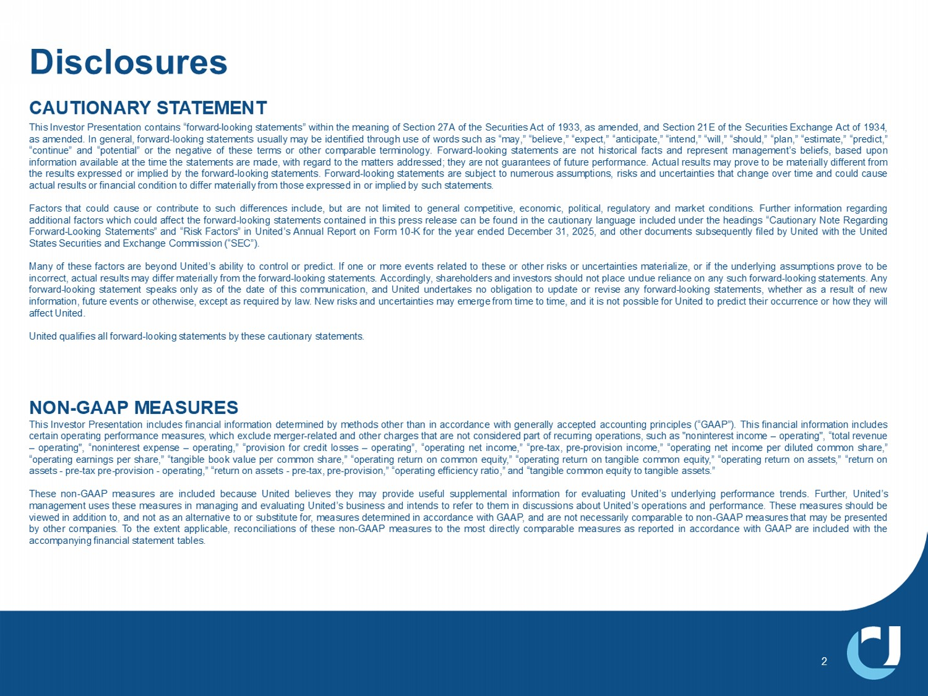
'LVFORVXUHV 2 CAUTIONARY STATEMENT This Investor Presentation contains “forward - looking statements” within the meaning of Section 27 A of the Securities Act of 1933 , as amended, and Section 21 E of the Securities Exchange Act of 1934 , as amended . In general, forward - looking statements usually may be identified through use of words such as “may,” “believe,” “expect,” “anticipate,” “intend,” “will,” “should,” “plan,” “estimate,” “predict,” “continue” and “potential” or the negative of these terms or other comparable terminology . Forward - looking statements are not historical facts and represent management’s beliefs, based upon information available at the time the statements are made, with regard to the matters addressed; they are not guarantees of future performance . Actual results may prove to be materially different from the results expressed or implied by the forward - looking statements . Forward - looking statements are subject to numerous assumptions, risks and uncertainties that change over time and could cause actual results or financial condition to differ materially from those expressed in or implied by such statements . Factors that could cause or contribute to such differences include, but are not limited to general competitive, economic, political, regulatory and market conditions . Further information regarding additional factors which could affect the forward - looking statements contained in this press release can be found in the cautionary language included under the headings “Cautionary Note Regarding Forward - Looking Statements” and “Risk Factors” in United’s Annual Report on Form 10 - K for the year ended December 31 , 2025 , and other documents subsequently filed by United with the United States Securities and Exchange Commission (“SEC”) . Many of these factors are beyond United’s ability to control or predict . If one or more events related to these or other risks or uncertainties materialize, or if the underlying assumptions prove to be incorrect, actual results may differ materially from the forward - looking statements . Accordingly, shareholders and investors should not place undue reliance on any such forward - looking statements . Any forward - looking statement speaks only as of the date of this communication, and United undertakes no obligation to update or revise any forward - looking statements, whether as a result of new information, future events or otherwise, except as required by law . New risks and uncertainties may emerge from time to time, and it is not possible for United to predict their occurrence or how they will affect United . United qualifies all forward - looking statements by these cautionary statements . NON - GAAP MEASURES This Investor Presentation includes financial information determined by methods other than in accordance with generally accepted accounting principles (“GAAP”) . This financial information includes certain operating performance measures, which exclude merger - related and other charges that are not considered part of recurring operations, such as "noninterest income – operating", “total revenue – operating", “ noninterest expense – operating,” “provision for credit losses – operating”, “operating net income,” “pre - tax, pre - provision income,” “operating net income per diluted common share,” “operating earnings per share,” “tangible book value per common share,” “operating return on common equity,” “operating return on tangible common equity,” “operating return on assets,” “return on assets - pre - tax pre - provision - operating,” “return on assets - pre - tax, pre - provision,” “operating efficiency ratio,” and “tangible common equity to tangible assets . ” These non - GAAP measures are included because United believes they may provide useful supplemental information for evaluating United’s underlying performance trends . Further, United’s management uses these measures in managing and evaluating United’s business and intends to refer to them in discussions about United’s operations and performance . These measures should be viewed in addition to, and not as an alternative to or substitute for, measures determined in accordance with GAAP, and are not necessarily comparable to non - GAAP measures that may be presented by other companies . To the extent applicable, reconciliations of these non - GAAP measures to the most directly comparable measures as reported in accordance with GAAP are included with the accompanying financial statement tables .

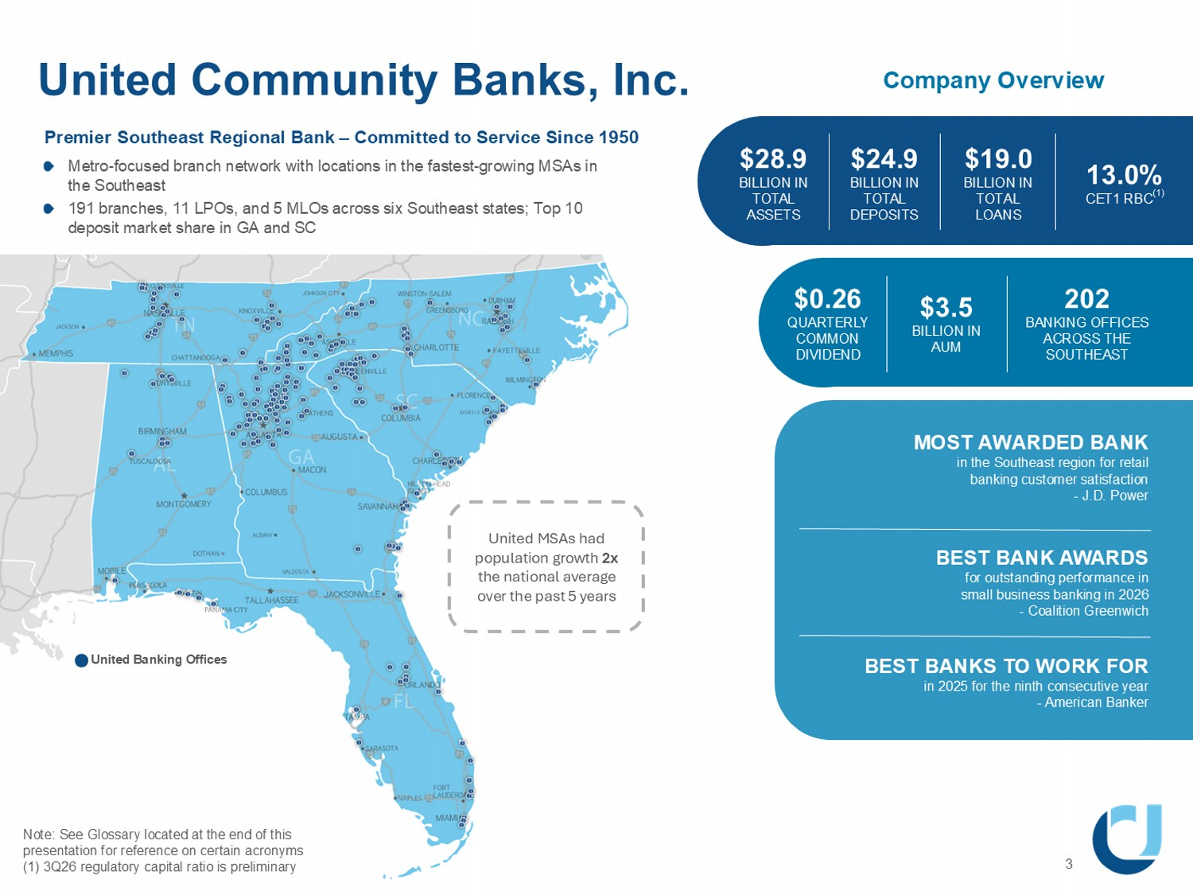
$28.9 BILLION IN TOTAL ASSETS United Community Banks, Inc. Note: See Glossary located at the end of this presentation for reference on certain acronyms (1) 3Q26 regulatory capital ratio is preliminary 3 8QLWHG%DQNLQJ2IILFHV Company Overview $24.9 BILLION IN TOTAL DEPOSITS $3.5 BILLION IN AUM 13.0% CET1 RBC (1) $19.0 BILLION IN TOTAL LOANS $0.26 QUARTERLY COMMON DIVIDEND 202 BANKING OFFICES ACROSS THE SOUTHEAST 0267$:$5'('%$1. LQWKH6RXWKHDVWUHJLRQIRUUHWDLO EDQNLQJFXVWRPHUVDWLVIDFWLRQ -'3RZHU BEST BANK AWARDS for outstanding performance in small business banking in 2026 - Coalition Greenwich BEST BANKS TO WORK FOR in 2025 for the ninth consecutive year - American Banker Premier Southeast Regional Bank – Committed to Service Since 1950 Metro - focused branch network with locations in the fastest - growing MSAs in the Southeast 191 branches, 11 LPOs, and 5 MLOs across six Southeast states; Top 10 deposit market share in GA and SC United MSAs had population growth 2x the national average over the past 5 years

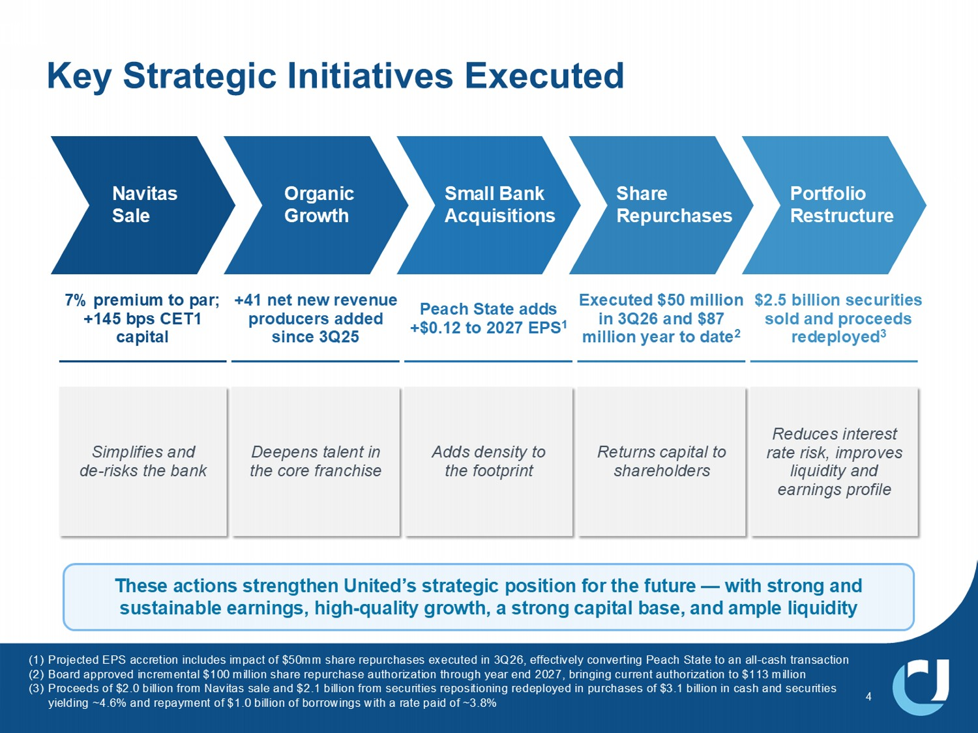
4 Key Strategic Initiatives Executed 7KHVHDFWLRQVVWUHQJWKHQ8QLWHG ¶ VVWUDWHJLFSRVLWLRQIRUWKHIXWXUH ² ZLWKVWURQJDQG VXVWDLQDEOHHDUQLQJVKLJK TXDOLW\JURZWKDVWURQJFDSLWDOEDVHDQGDPSOHOLTXLGLW\ 7% premium to par; +145 bps CET1 capital Simplifies and de - risks the bank +41 net new revenue producers added since 3Q25 Deepens talent in the core franchise Peach State adds +$0.12 to 2027 EPS 1 Adds density to the footprint Executed $50 million in 3Q26 and $87 million year to date 2 5HWXUQV FDSLWDO WR VKDUHKROGHUV $2.5 billion securities sold and proceeds redeployed 3 Reduces interest rate risk, improves liquidity and earnings profile Portfolio Restructure Share Repurchases Small Bank Acquisitions Organic Growth Navitas Sale 3URMHFWHG(36DFFUHWLRQLQFOXGHVLPSDFWRI PPVKDUHUHSXUFKDVHVH[HFXWHGLQ 4 HIIHFWLYHO\FRQYHUWLQJ3HDFK6WDWHWRDQDOO FDVKWUDQVDFWLRQ %RDUGDSSURYHGLQFUHPHQWDO PLOOLRQVKDUHUHSXUFKDVHDXWKRUL]DWLRQWKURXJK\HDUHQG EULQJLQJFXUUHQWDXWKRUL]DWLRQWR PLOOLRQ 3URFHHGVRI ELOOLRQIURP1DYLWDVVDOHDQG ELOOLRQIURPVHFXULWLHVUHSRVLWLRQLQJUHGHSOR\HGLQSXUFKDVHVRI ELOOLRQLQFDVKDQGVHFXULWLHV \LHOGLQJa DQGUHSD\PHQWRI ELOOLRQRIERUURZLQJVZLWKDUDWHSDLGRIa

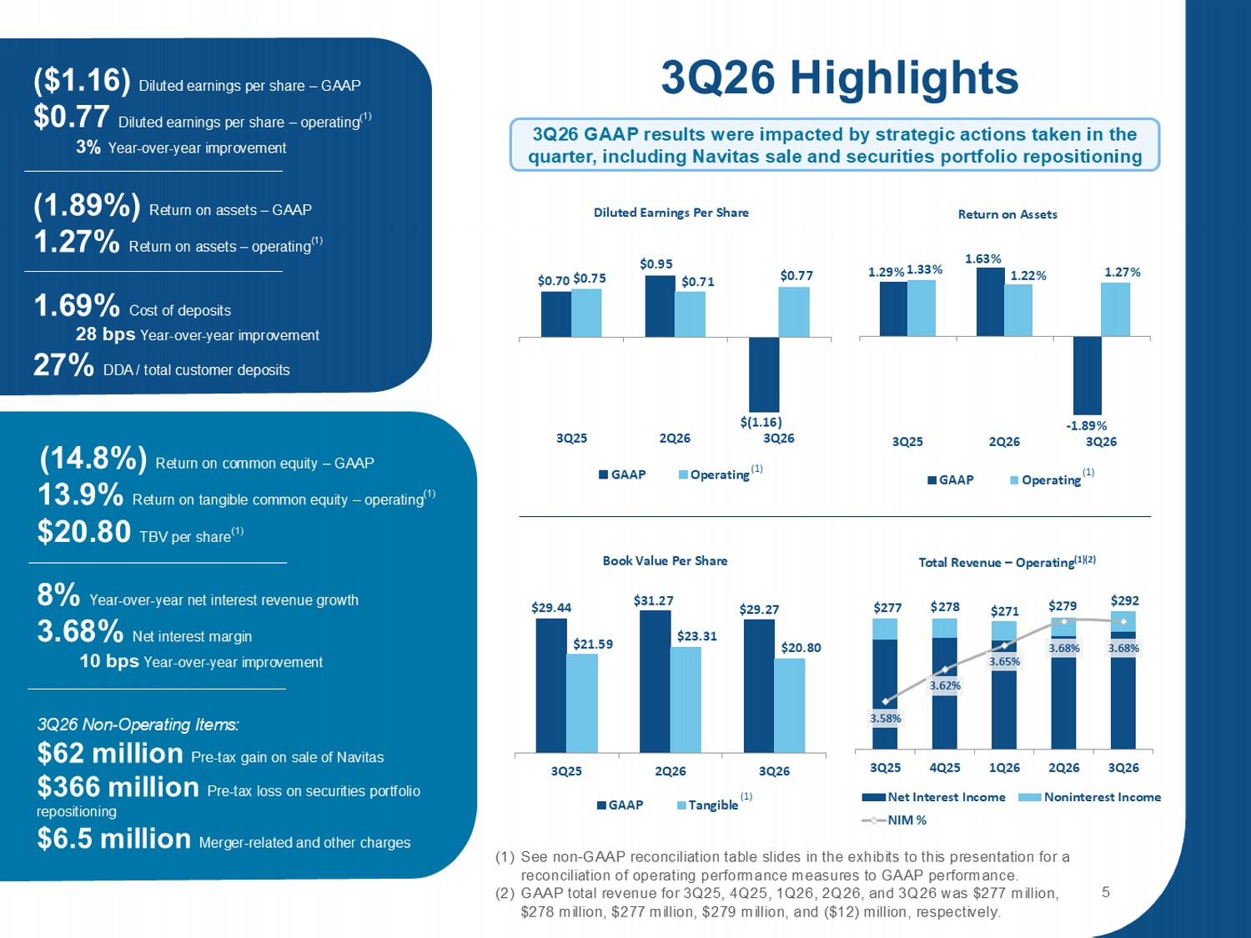
1.29% 1.63% - 1.89% 1.33% 1.22% 1.27% 3Q25 2Q26 3Q26 Return on Assets GAAP Operating ; $0.95 $(1.16) $0.75 $0.71 $0.77 3Q25 2Q26 3Q26 Diluted Earnings Per Share GAAP Operating $29.44 ϯϭϮ; $29.27 $21.59 $23.31 $20.80 3Q25 2Q26 3Q26 Book Value Per Share GAAP Tangible 1.01% Return on assets – operating (1) 3Q26 Highlights 6HHQRQ *$$3UHFRQFLOLDWLRQWDEOHVOLGHVLQWKHH[KLELWVWRWKLVSUHVHQWDWLRQIRUD UHFRQFLOLDWLRQRIRSHUDWLQJSHUIRUPDQFHPHDVXUHVWR*$$3SHUIRUPDQFH *$$3WRWDOUHYHQXHIRU 4 4 4 4 DQG 4 ZDV PLOOLRQ PLOOLRQ PLOOLRQ PLOOLRQDQG PLOOLRQUHVSHFWLYHO\ $277 $278 $271 $279 $292 3.58% 3.62% ϯϲϱ й 3.68% 3.68% 3Q25 4Q25 1Q26 2Q26 3Q26 Total Revenue – Operating (1)(2) Net Interest Income Noninterest Income NIM % 5 (1) (1) ($1.16) Diluted earnings per share – GAAP $0.77 Diluted earnings per share – operating ( 1) 3% Year - over - year improvement 5HWXUQRQDVVHWV ± *$$3 5HWXUQRQDVVHWV ± RSHUDWLQJ 1.69% Cost of deposits 28 bps Year - over - year improvement 27% DDA / total customer deposits (14.8%) Return on common equity – GAAP 13.9% Return on tangible common equity – operating (1) $20.80 TBV per share (1) 8% Year - over - year net interest revenue growth 3.68% Net interest margin 10 bps Year - over - year improvement (1) 3Q26 Non - Operating Items: $62 million Pre - tax gain on sale of Navitas $366 million Pre - tax loss on securities portfolio repositioning $6.5 million Merger - related and other charges 3Q26 GAAP results were impacted by strategic actions taken in the quarter, including Navitas sale and securities portfolio repositioning

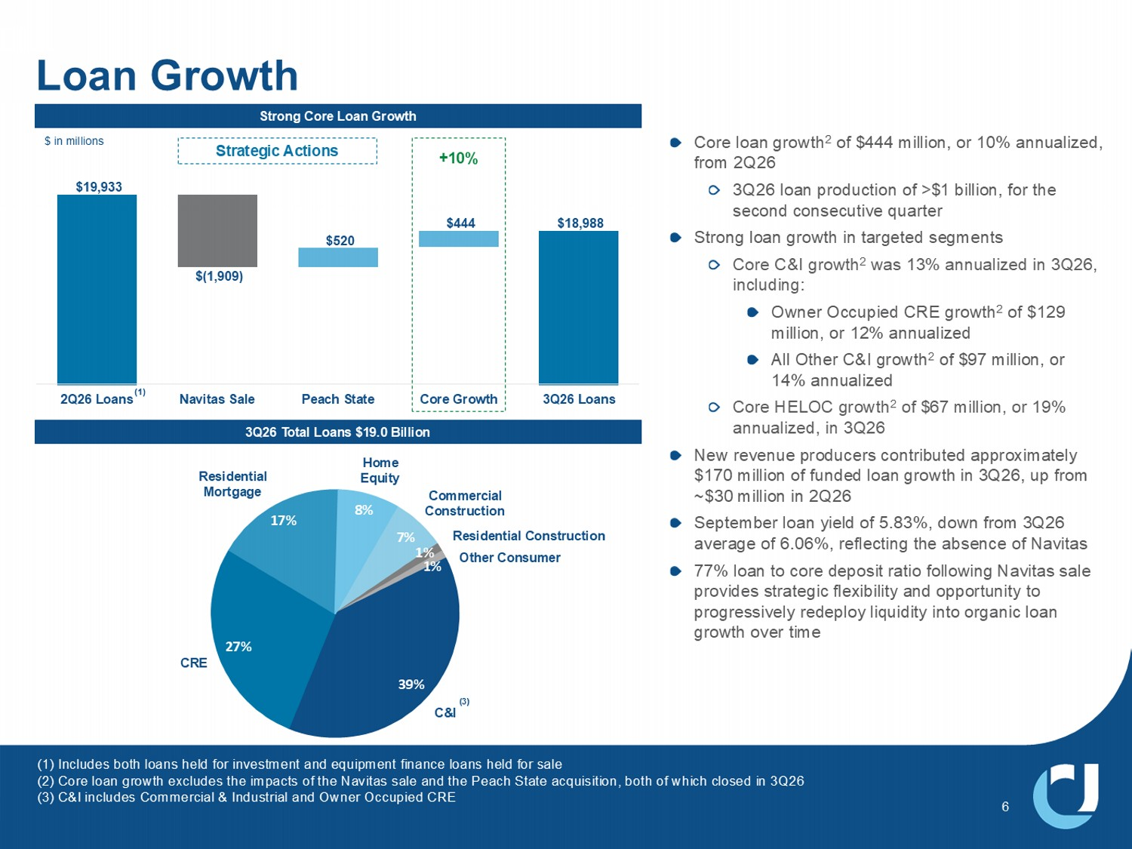
7% ϭ й 1% 39% 27% 17% 8% C&I Commercial Construction &5( Other Consumer Residential Mortgage Home Equity Residential Construction $19,933 $520 $444 $18,988 2Q26 Loans Navitas Sale Peach State Core Growth 3Q26 Loans Strong Core Loan Growth Core loan growth 2 of $444 million, or 10% annualized, from 2Q26 3Q26 loan production of >$1 billion, for the second consecutive quarter Strong loan growth in targeted segments Core C&I growth 2 was 13% annualized in 3Q26, including: Owner Occupied CRE growth 2 of $129 million, or 12% annualized All Other C&I growth 2 of $97 million, or 14% annualized Core HELOC growth 2 of $67 million, or 19% annualized, in 3Q26 New revenue producers contributed approximately $170 million of funded loan growth in 3Q26, up from ~$30 million in 2Q26 September loan yield of 5.83%, down from 3Q26 average of 6.06%, reflecting the absence of Navitas 77% loan to core deposit ratio following Navitas sale provides strategic flexibility and opportunity to progressively redeploy liquidity into organic loan growth over time 6 3Q26 Total Loans $19.0 Billion $ in millions ,QFOXGHVERWKORDQVKHOGIRULQYHVWPHQWDQGHTXLSPHQWILQDQFHORDQVKHOGIRUVDOH &RUHORDQJURZWKH[FOXGHVWKHLPSDFWVRIWKH1DYLWDVVDOHDQGWKH3HDFK6WDWHDFTXLVLWLRQERWKRIZKLFKFORVHGLQ 4 & ,LQFOXGHV&RPPHUFLDO ,QGXVWULDODQG2ZQHU2FFXSLHG&5( (1) +10% Strategic Actions (3) EB1

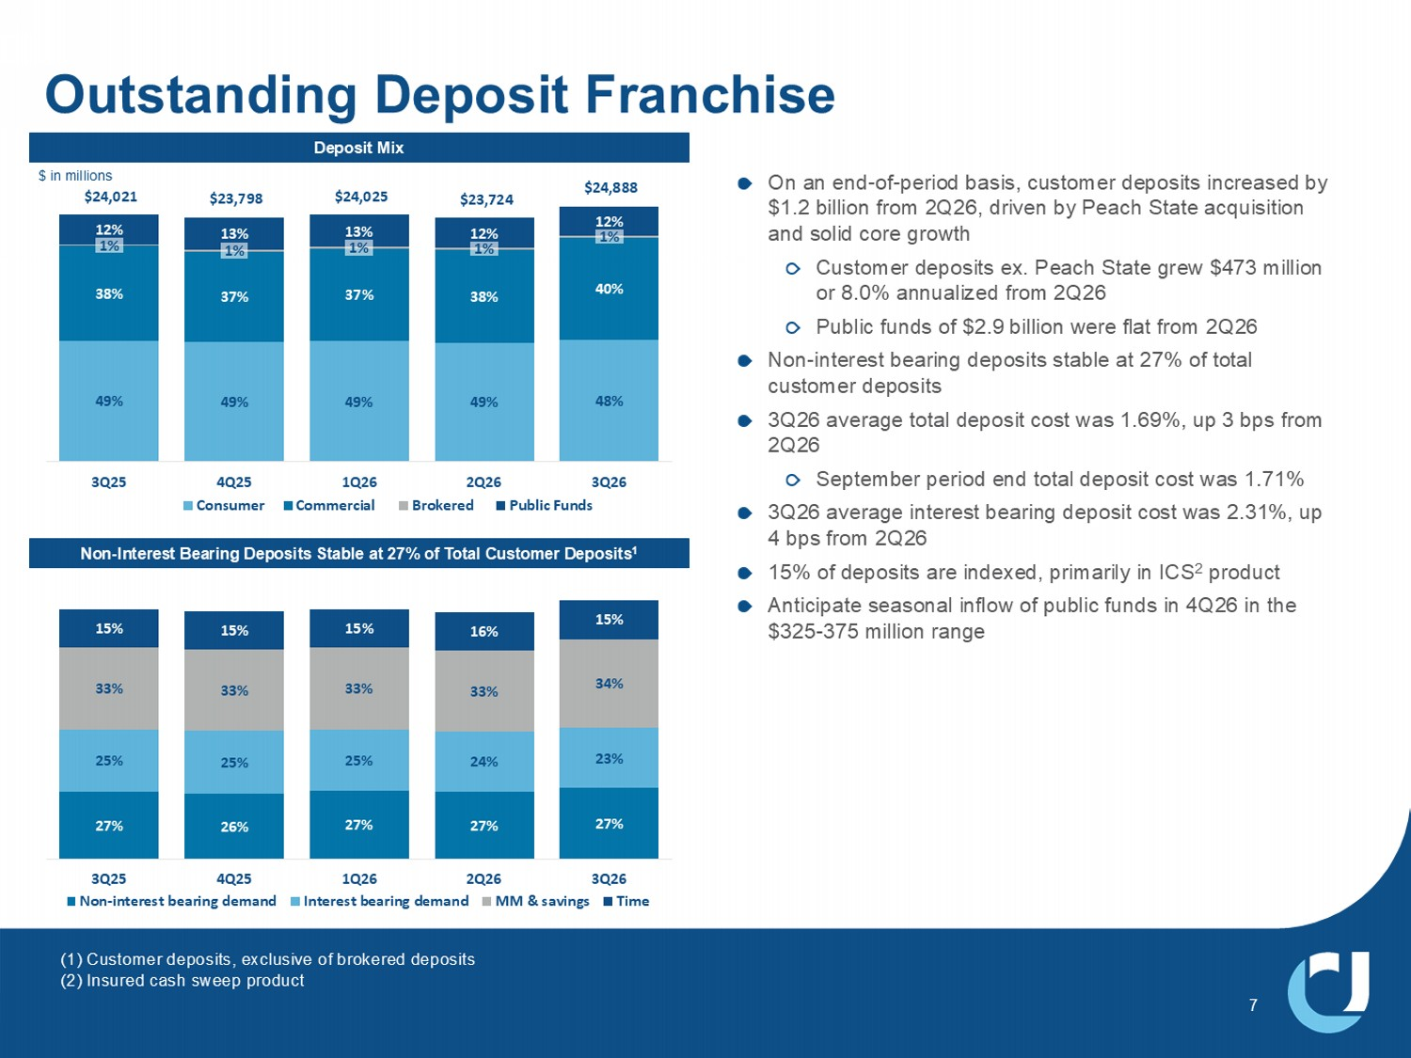
49% 49% 49% ϰϵ й 48% 38% 37% 37% 38% 40% 1% ϭ й 1% 1% 1% 12% 13% 13% 12% ϭϮ й $24,021 $23,798 $24,025 $23,724 $24,888 3Q25 4Q25 1Q26 2Q26 3Q26 Consumer Commercial Brokered Public Funds Outstanding Deposit Franchise Non - Interest Bearing Deposits Stable at 27% of Total Customer Deposits 1 On an end - of - period basis, customer deposits increased by $1.2 billion from 2Q26, driven by Peach State acquisition and solid core growth Customer deposits ex. Peach State grew $473 million or 8.0% annualized from 2Q26 Public funds of $2.9 billion were flat from 2Q26 Non - interest bearing deposits stable at 27% of total customer deposits 3Q26 average total deposit cost was 1.69%, up 3 bps from 2Q26 September period end total deposit cost was 1.71% 3Q26 average interest bearing deposit cost was 2.31%, up 4 bps from 2Q26 15% of deposits are indexed, primarily in ICS 2 product Anticipate seasonal inflow of public funds in 4Q26 in the $325 - 375 million range Deposit Mix 27% 26% 27% 27% 27% Ϯϱ й 25% 25% 24% 23% 33% 33% 33% ϯϯ й 34% 15% 15% 15% 16% 15% 3Q25 4Q25 1Q26 2Q26 3Q26 Non-interest bearing demand Interest bearing demand MM & savings Time (1) Customer deposits, exclusive of brokered deposits (2) Insured cash sweep product LQPLOOLRQV

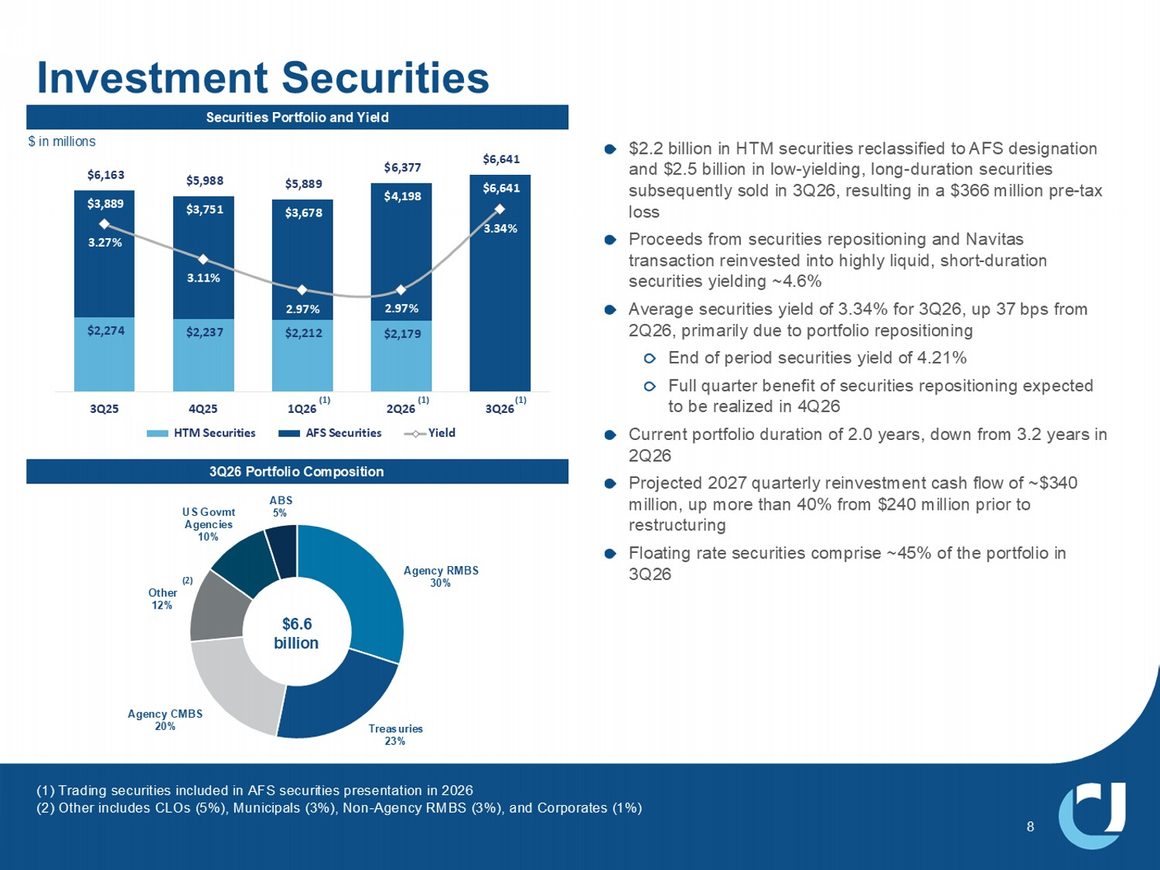
$2,274 $2,237 $2,212 $2,179 ϯ͕ϴϴϵ $3,751 $3,678 $4,198 $6,641 $6,163 $5,988 $5,889 ϲ͕ϯ;; $6,641 3.27% 3.11% 2.97% 2.97% 3.34% 3Q25 4Q25 1Q26 2Q26 3Q26 HTM Securities AFS Securities Yield Investment Securities $2.2 billion in HTM securities reclassified to AFS designation and $2.5 billion in low - yielding, long - duration securities subsequently sold in 3Q26, resulting in a $366 million pre - tax loss Proceeds from securities repositioning and Navitas transaction reinvested into highly liquid, short - duration securities yielding ~4.6% Average securities yield of 3.34% for 3Q26, up 37 bps from 2Q26, primarily due to portfolio repositioning End of period securities yield of 4.21% Full quarter benefit of securities repositioning expected to be realized in 4Q26 Current portfolio duration of 2.0 years, down from 3.2 years in 2Q26 Projected 2027 quarterly reinvestment cash flow of ~$340 million, up more than 40% from $240 million prior to restructuring Floating rate securities comprise ~45% of the portfolio in 3Q26 $ in millions Securities Portfolio and Yield Agency RMBS 30% Treasuries 23% Agency CMBS 20% Other 12% 86*RYPW $JHQFLHV ABS 5% (1) (1) Trading securities included in AFS securities presentation in 2026 (2) Other includes CLOs (5%), Municipals (3%), Non - Agency RMBS (3%), and Corporates (1%) 3Q26 Portfolio Composition (1) (1) $6.6 billion ; Ϯ Ϳ

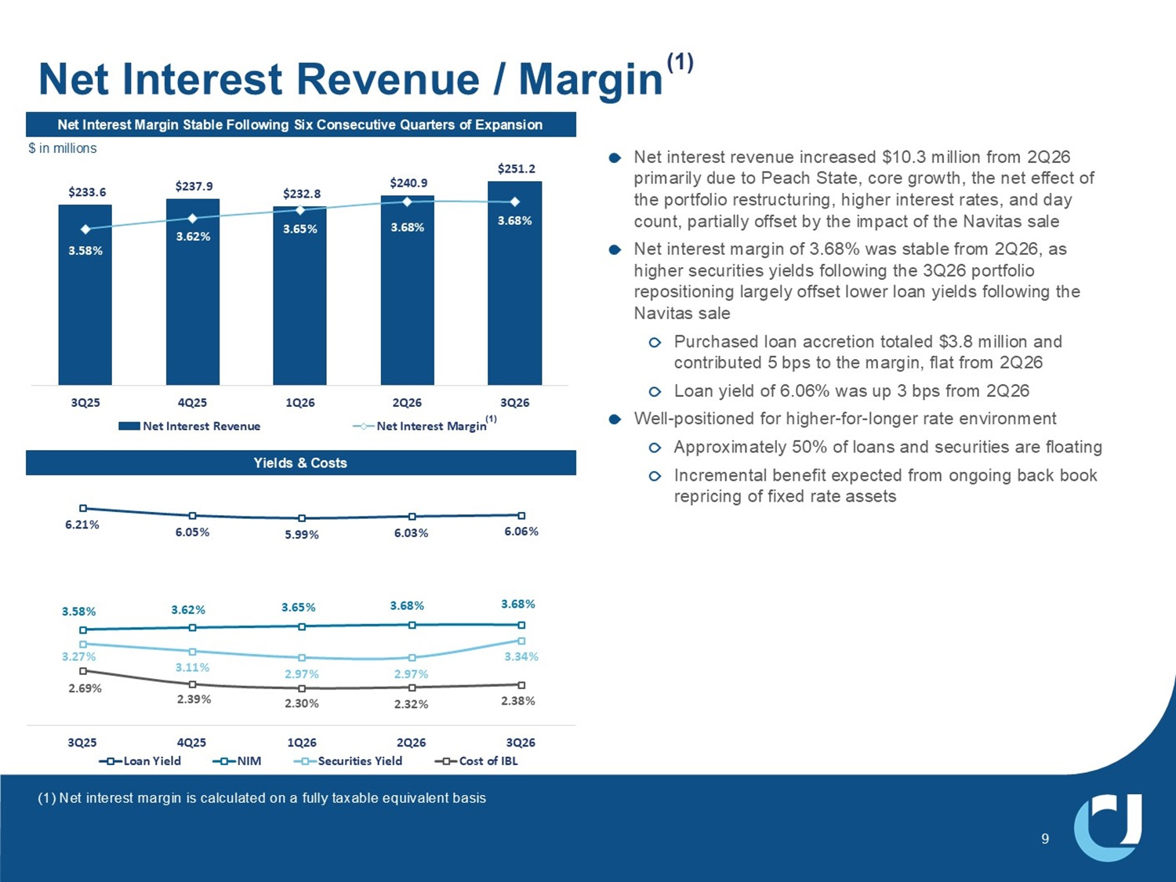
$233.6 $237.9 ϮϯϮϴ $240.9 $251.2 3.58% 3.62% 3.65% 3.68% 3.68% $100.0 $120.0 $140.0 $160.0 $180.0 $200.0 $220.0 $240.0 $260.0 3.00% 3.10% 3.20% 3.30% 3.40% 3.50% 3.60% 3.70% 3.80% 3Q25 4Q25 1Q26 2Q26 3Q26 Net Interest Revenue Net Interest Margin 1HW,QWHUHVW0DUJLQ6WDEOH)ROORZLQJ6L[&RQVHFXWLYH4XDUWHUVRI([SDQVLRQ Net interest revenue increased $10.3 million from 2Q26 primarily due to Peach State, core growth, the net effect of the portfolio restructuring, higher interest rates, and day count, partially offset by the impact of the Navitas sale Net interest margin of 3.68% was stable from 2Q26, as higher securities yields following the 3Q26 portfolio repositioning largely offset lower loan yields following the Navitas sale Purchased loan accretion totaled $3.8 million and contributed 5 bps to the margin, flat from 2Q26 Loan yield of 6.06% was up 3 bps from 2Q26 Well - positioned for higher - for - longer rate environment Approximately 50% of loans and securities are floating Incremental benefit expected from ongoing back book repricing of fixed assets Net Interest Revenue / Margin (1) Yields & Costs 6.21% 6.05% 5.99% ϲϯ й 6.06% 3.58% 3.62% 3.65% 3.68% 3.68% 3.27% ϯϭϭ й 2.97% 2.97% 3.34% 2.69% 2.39% 2.30% 2.32% Ϯϯϴ й 3Q25 4Q25 1Q26 2Q26 3Q26 Loan Yield NIM Securities Yield Cost of IBL (1) Net interest margin is calculated on a fully taxable equivalent basis (1) 9 $ in millions

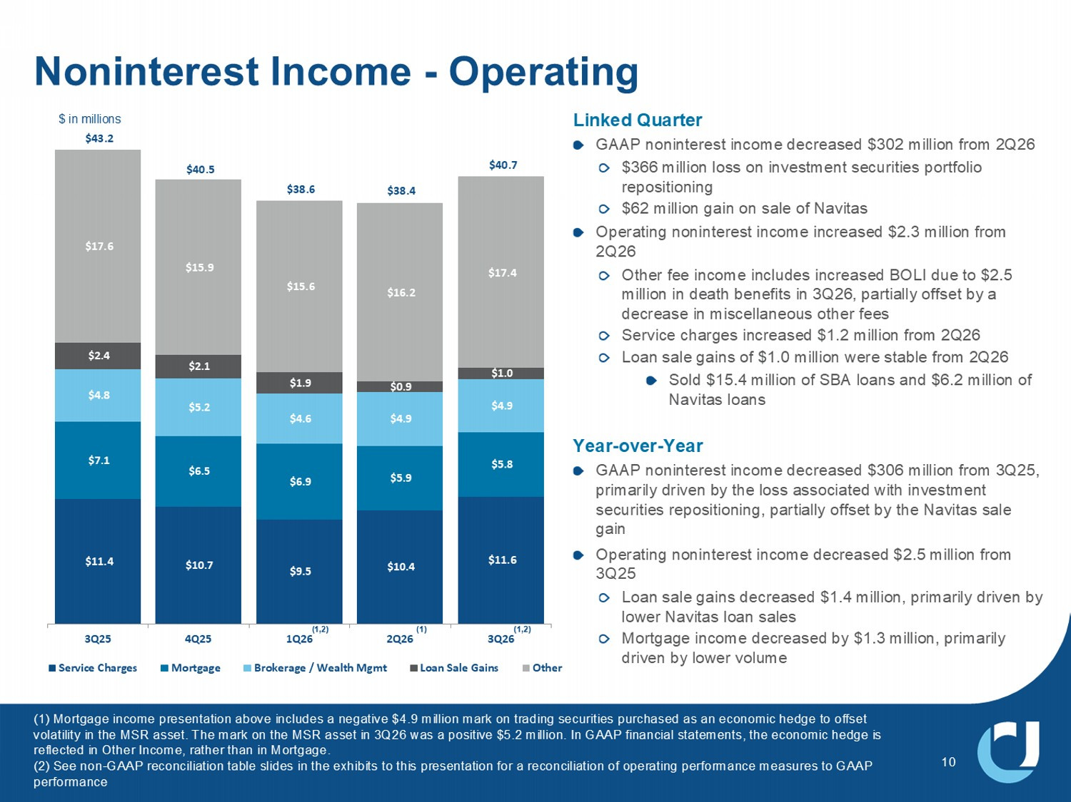
$11.4 ϭ; $9.5 $10.4 $11.6 $7.1 $6.5 $6.9 $5.9 ϱϴ $4.8 $5.2 $4.6 $4.9 $4.9 $2.4 $2.1 ϭϵ $0.9 $1.0 $17.6 $15.9 $15.6 $16.2 $17.4 3Q25 4Q25 1Q26 2Q26 3Q26 Service Charges Mortgage Brokerage / Wealth Mgmt Loan Sale Gains Other /LQNHG4XDUWHU *$$3QRQLQWHUHVWLQFRPHGHFUHDVHG PLOOLRQIURP 4 PLOOLRQORVVRQLQYHVWPHQWVHFXULWLHVSRUWIROLR UHSRVLWLRQLQJ PLOOLRQJDLQRQVDOHRI1DYLWDV 2SHUDWLQJQRQLQWHUHVWLQFRPHLQFUHDVHG PLOOLRQIURP 4 2WKHUIHHLQFRPHLQFOXGHVLQFUHDVHG%2/,GXHWR PLOOLRQLQGHDWKEHQHILWVLQ 4 SDUWLDOO\RIIVHWE\D GHFUHDVHLQPLVFHOODQHRXVRWKHUIHHV 6HUYLFHFKDUJHVLQFUHDVHG PLOOLRQIURP 4 /RDQVDOHJDLQVRI PLOOLRQZHUHVWDEOHIURP 4 6ROG PLOOLRQRI6%$ORDQVDQG PLOOLRQRI 1DYLWDVORDQV <HDU RYHU <HDU *$$3QRQLQWHUHVWLQFRPHGHFUHDVHG PLOOLRQIURP 4 SULPDULO\GULYHQE\WKHORVVDVVRFLDWHGZLWKLQYHVWPHQW VHFXULWLHVUHSRVLWLRQLQJSDUWLDOO\RIIVHWE\WKH1DYLWDVVDOH JDLQ 2SHUDWLQJQRQLQWHUHVWLQFRPHGHFUHDVHG PLOOLRQIURP 4 /RDQVDOHJDLQVGHFUHDVHG PLOOLRQSULPDULO\GULYHQE\ ORZHU1DYLWDVORDQVDOHV 0RUWJDJHLQFRPHGHFUHDVHGE\ PLOOLRQSULPDULO\ GULYHQE\ORZHUYROXPH 10 Noninterest Income - Operating $ in millions $40.7 $43.2 $40.5 $38.6 0RUWJDJHLQFRPHSUHVHQWDWLRQDERYHLQFOXGHVDQHJDWLYH PLOOLRQPDUNRQWUDGLQJVHFXULWLHVSXUFKDVHGDVDQHFRQRPLFKHGJHWRRIIVHW YRODWLOLW\LQWKH065DVVHW7KHPDUNRQWKH065DVVHWLQ 4 ZDVDSRVLWLYH PLOOLRQ,Q*$$3ILQDQFLDOVWDWHPHQWVWKHHFRQRPLFKHGJHLV UHIOHFWHGLQ2WKHU,QFRPHUDWKHUWKDQLQ0RUWJDJH 6HHQRQ *$$3UHFRQFLOLDWLRQWDEOHVOLGHVLQWKHH[KLELWVWRWKLVSUHVHQWDWLRQIRUDUHFRQFLOLDWLRQRIRSHUDWLQJSHUIRUPDQFHPH DVXUHVWR*$$3 SHUIRUPDQFH (1,2) (1,2) $38.4 (1)

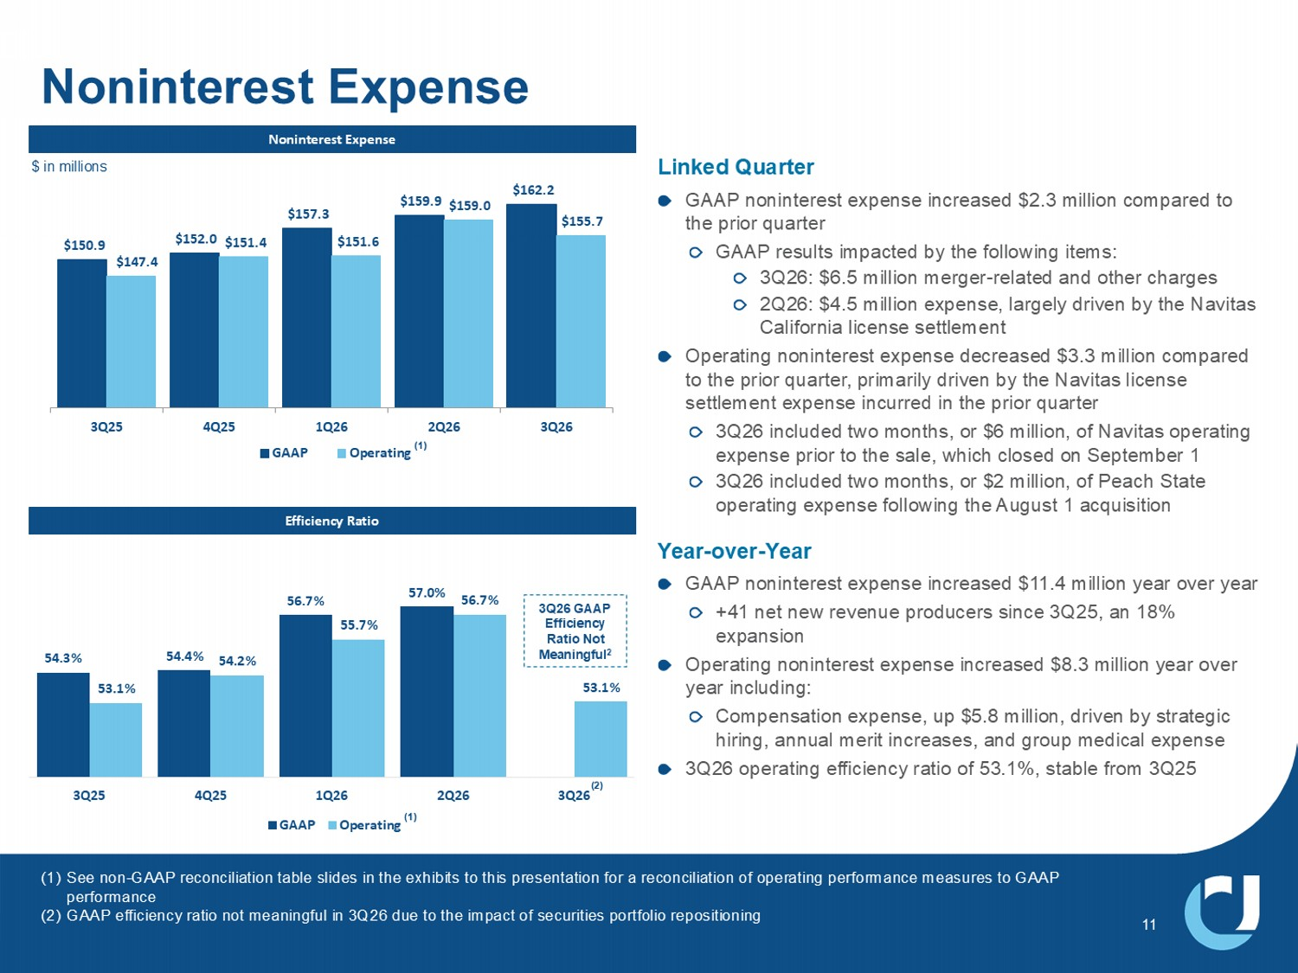
$150.9 $152.0 $157.3 $159.9 ϭϲϮϮ $147.4 $151.4 $151.6 $159.0 $155.7 3Q25 4Q25 1Q26 2Q26 3Q26 GAAP Operating Noninterest Expense Efficiency Ratio EŽŶŝŶƚĞƌĞƐƚǆƉĞŶƐĞ 54.3% 54.4% 56.7% 57.0% 53.1% 54.2% 55.7% ϱϲ; й 53.1% 3Q25 4Q25 1Q26 2Q26 3Q26 GAAP Operating Linked Quarter GAAP noninterest expense increased $2.3 million compared to the prior quarter GAAP results impacted by the following items: 3Q26: $6.5 million merger - related and other charges 2Q26: $4.5 million expense, largely driven by the Navitas California license settlement Operating noninterest expense decreased $3.3 million compared to the prior quarter, primarily driven by the Navitas license settlement expense incurred in the prior quarter 3Q26 included two months, or $6 million, of Navitas operating expense prior to the sale, which closed on September 1 3Q26 included two months, or $2 million, of Peach State operating expense following the August 1 acquisition Year - over - Year GAAP noninterest expense increased $11.4 million year over year +41 net new revenue producers since 3Q25, an 18% expansion Operating noninterest expense increased $8.3 million year over year including: Compensation expense, up $5.8 million, driven by strategic hiring, annual merit increases, and group medical expense 3Q26 operating efficiency ratio of 53.1%, stable from 3Q25 11 (1) See non - GAAP reconciliation table slides in the exhibits to this presentation for a reconciliation of operating performance meas ures to GAAP performance (2) GAAP efficiency ratio not meaningful in 3Q26 due to the impact of securities portfolio repositioning (1) $ in millions (1) 3Q26 GAAP Efficiency Ratio Not Meaningful 2

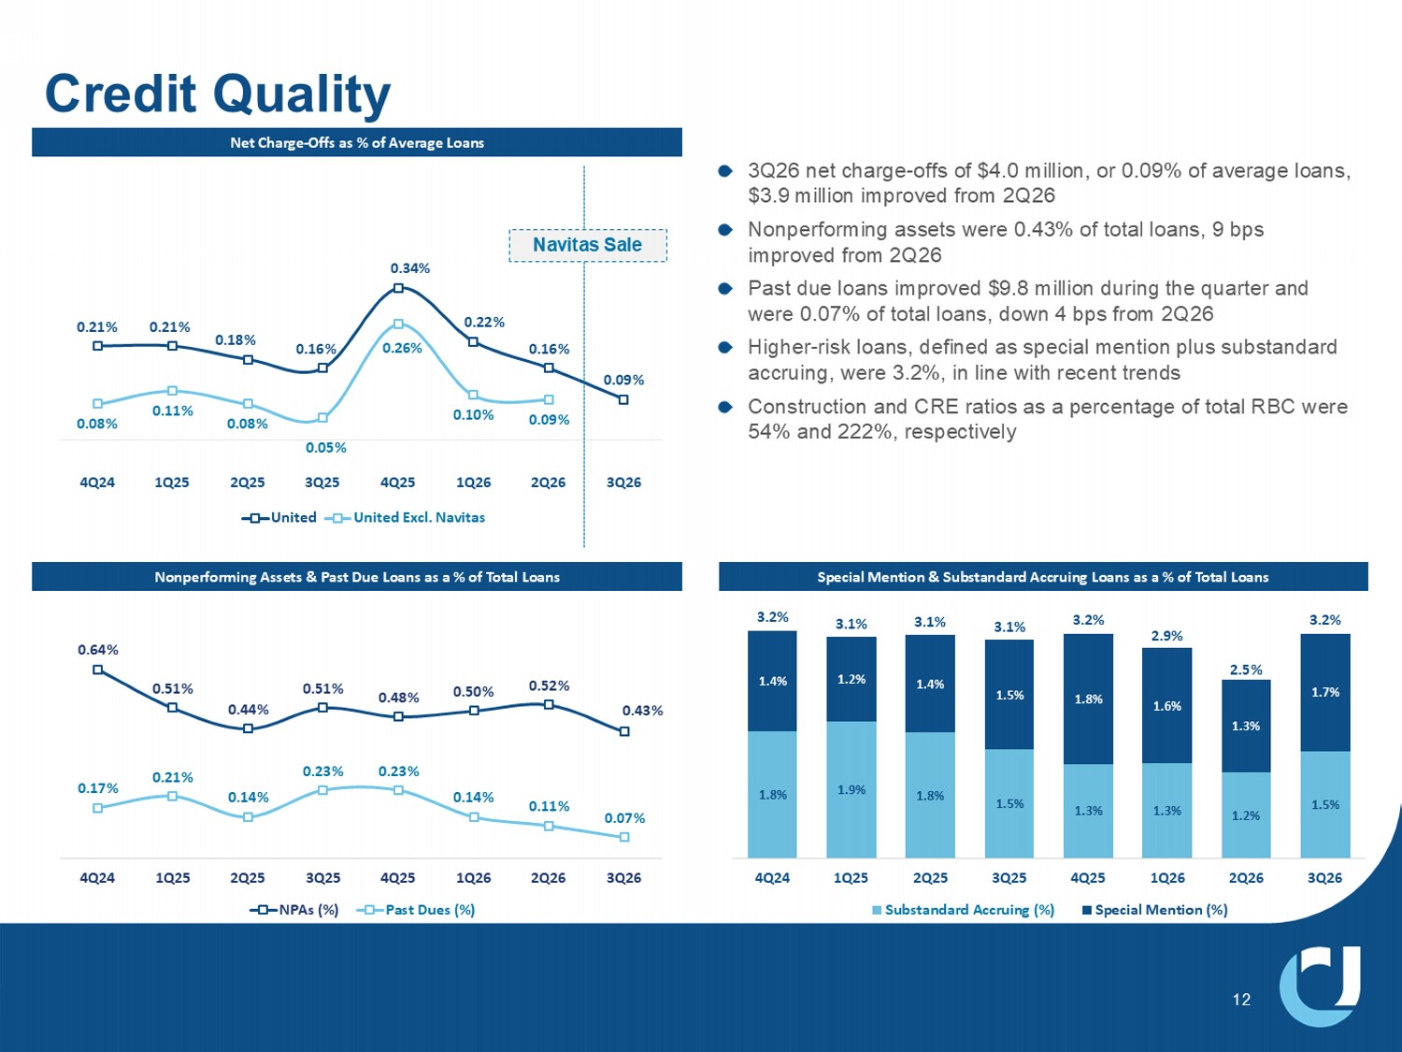
3Q26 net charge - offs of $4.0 million, or 0.09% of average loans, $3.9 million improved from 2Q26 Nonperforming assets were 0.43% of total loans, 9 bps improved from 2Q26 Past due loans improved $9.8 million during the quarter and were 0.07% of total loans, down 4 bps from 2Q26 Higher - risk loans, defined as special mention plus substandard accruing, were 3.2%, in line with recent trends Construction and CRE ratios as a percentage of total RBC were 54% and 222%, respectively Credit Quality EĞƚŚĂƌŐĞ Ͳ KĨĨƐĂƐйŽĨǀĞƌĂŐĞ>ŽĂŶƐ Nonperforming Assets & Past Due Loans as a % of Total Loans 0.64% 0.51% 0.44% 0.51% 0.48% 0.50% ϱϮ й 0.43% 0.17% 0.21% 0.14% 0.23% 0.23% 0.14% ϭϭ й 0.07% 4Q24 1Q25 2Q25 3Q25 4Q25 1Q26 2Q26 3Q26 NPAs (%) Past Dues (%) 1.8% 1.9% 1.8% 1.5% 1.3% 1.3% ϭϮ й 1.5% 1.4% 1.2% 1.4% 1.5% 1.8% 1.6% ϭϯ й 1.7% 3.2% 3.1% 3.1% 3.1% 3.2% 2.9% Ϯϱ й 3.2% 4Q24 1Q25 2Q25 3Q25 4Q25 1Q26 2Q26 3Q26 Substandard Accruing (%) Special Mention (%) Special Mention & Substandard Accruing Loans as a % of Total Loans 12 0.21% 0.21% 0.18% 0.16% ϯϰ й 0.22% 0.16% 0.09% 0.08% 0.11% 0.08% 0.05% Ϯϲ й 0.10% 0.09% 4Q24 1Q25 2Q25 3Q25 4Q25 1Q26 2Q26 3Q26 United United Excl. Navitas Navitas Sale

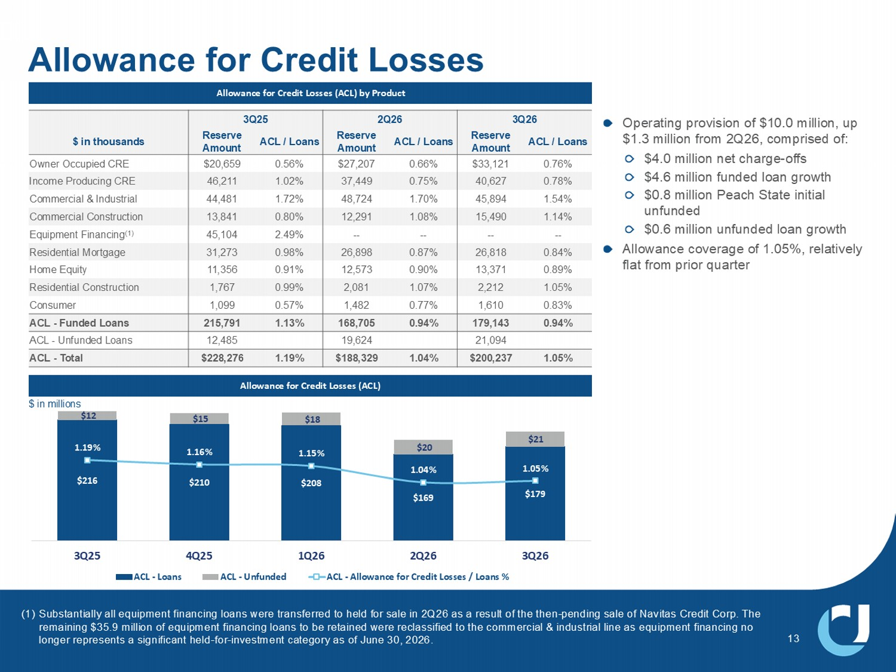
Allowance for Credit Losses Allowance for Credit Losses (ACL) by Product Allowance for Credit Losses (ACL) Operating provision of $10.0 million, up $1.3 million from 2Q26, comprised of: $4.0 million net charge - offs $4.6 million funded loan growth $0.8 million Peach State initial unfunded $0.6 million unfunded loan growth Allowance coverage of 1.05%, relatively flat from prior quarter $216 $210 $208 $169 $179 $12 $15 $18 $20 $21 1.19% 1.16% 1.15% 1.04% 1.05% 0.65% 0.75% 0.85% 0.95% 1.05% 1.15% 1.25% 1.35% 1.45% 1.55% $50 $70 $90 $110 $130 $150 $170 $190 $210 $230 3Q25 4Q25 1Q26 2Q26 3Q26 ACL - Loans ACL - Unfunded ACL - Allowance for Credit Losses / Loans % 13 $ in millions 4 2Q26 3Q25 ACL / Loans Reserve Amount ACL / Loans Reserve Amount ACL / Loans Reserve Amount $ in thousands 0.76% $33,121 0.66% $27,207 0.56% $20,659 Owner Occupied CRE 0.78% 40,627 0.75% 37,449 1.02% 46,211 Income Producing CRE 1.54% 45,894 1.70% 48,724 1.72% 44,481 Commercial & Industrial 1.14% 15,490 1.08% 12,291 0.80% 13,841 Commercial Construction -- -- -- -- 2.49% 45,104 Equipment Financing (1) 0.84% 26,818 0.87% 26,898 0.98% 31,273 Residential Mortgage 0.89% 13,371 0.90% 12,573 0.91% 11,356 Home Equity 1.05% 2,212 1.07% 2,081 0.99% 1,767 Residential Construction 0.83% 1,610 0.77% 1,482 0.57% 1,099 Consumer 0.94% 179,143 0.94% 168,705 1.13% 215,791 ACL - Funded Loans 21,094 19,624 12,485 ACL - Unfunded Loans 1.05% $200,237 1.04% $188,329 1.19% $228,276 ACL - Total (1) Substantially all equipment financing loans were transferred to held for sale in 2Q26 as a result of the then - pending sale of Na vitas Credit Corp. The remaining $35.9 million of equipment financing loans to be retained were reclassified to the commercial & industrial line as equ ipment financing no longer represents a significant held - for - investment category as of June 30, 2026.

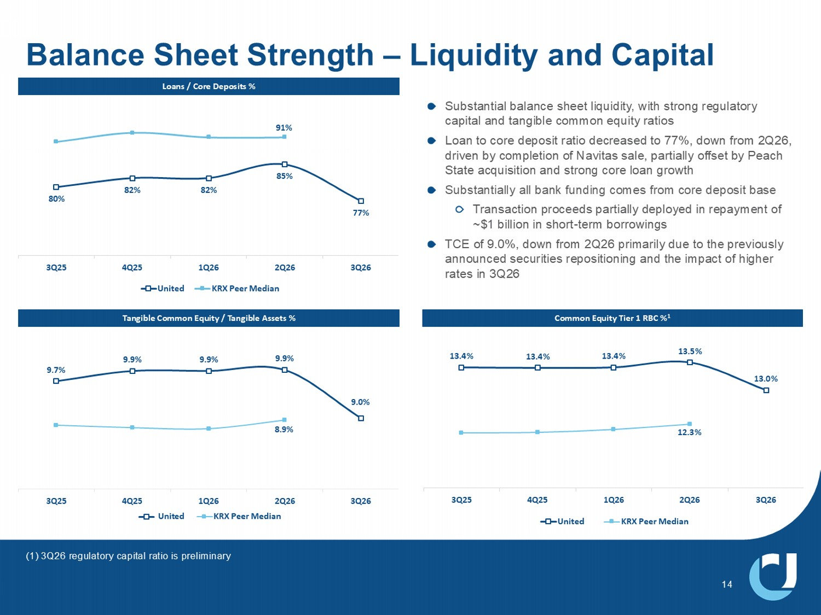
80% 82% 82% 85% 77% 91% 3Q25 4Q25 1Q26 2Q26 3Q26 United KRX Peer Median Substantial balance sheet liquidity, with strong regulatory capital and tangible common equity ratios Loan to core deposit ratio decreased to 77%, down from 2Q26, driven by completion of Navitas sale, partially offset by Peach State acquisition and strong core loan growth Substantially all bank funding comes from core deposit base Transaction proceeds partially deployed in repayment of ~$1 billion in short - term borrowings TCE of 9.0%, down from 2Q26 primarily due to the previously announced securities repositioning and the impact of higher rates in 3Q26 9.7% 9.9% 9.9% 9.9% 9.0% 8.9% 3Q25 4Q25 1Q26 2Q26 3Q26 United KRX Peer Median Loans / Core Deposits % Tangible Common Equity / Tangible Assets % Common Equity Tier 1 RBC % 1 13.4% 13.4% 13.4% 13.5% 13.0% 12.3% 3Q25 4Q25 1Q26 2Q26 3Q26 United KRX Peer Median Balance Sheet Strength – Liquidity and Capital 14 (1) 3Q26 regulatory capital ratio is preliminary

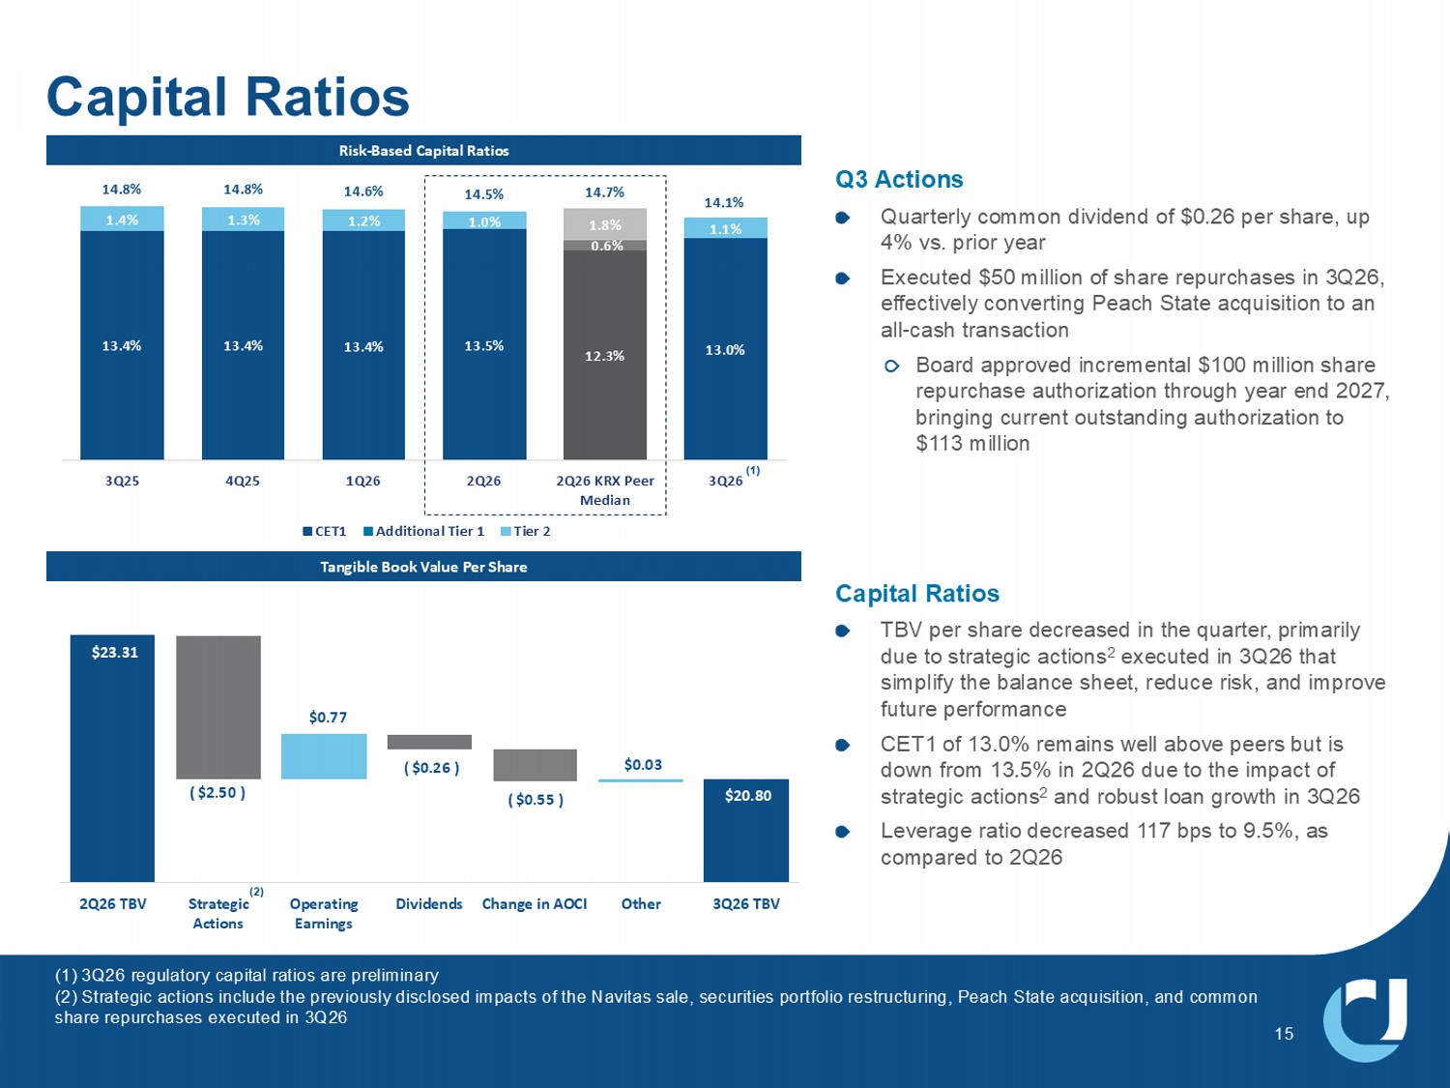
15 Risk - Based Capital Ratios Tangible Book Value Per Share Q3 Actions Quarterly common dividend of $0.26 per share, up 4% vs. prior year Executed $50 million of share repurchases in 3Q26, effectively converting Peach State acquisition to an all - cash transaction Board approved incremental $100 million share repurchase authorization through year end 2027, bringing current outstanding authorization to $113 million x Capital Ratios TBV per share decreased in the quarter, primarily due to strategic actions 2 executed in 3Q26 that simplify the balance sheet, reduce risk, and improve future performance CET1 of 13.0% remains well above peers but is down from 13.5% in 2Q26 due to the impact of strategic actions 2 and robust loan growth in 3Q26 Leverage ratio decreased 117 bps to 9.5%, as compared to 2Q26 13.4% 13.4% 13.4% 13.5% 12.3% 13.0% 0.6% 1.4% 1.3% 1.2% 1.0% 1.8% 1.1% 14.8% 14.8% 14.6% 14.5% 14.7% 14.1% 3Q25 4Q25 1Q26 2Q26 2Q26 KRX Peer Median 3Q26 CET1 Additional Tier 1 Tier 2 Capital Ratios $20.80 $23.31 ( $2.50 ) $0.77 ( $0.26 ) ( $0.55 ) $0.03 2Q26 TBV Strategic Actions Operating Earnings Dividends Change in AOCI Other 3Q26 TBV (1) 3Q26 regulatory capital ratios are preliminary (2) Strategic actions include the previously disclosed impacts of the Navitas sale, securities portfolio restructuring, Peach St ate acquisition, and common share repurchases executed in 3Q26 (2) (1) EB1

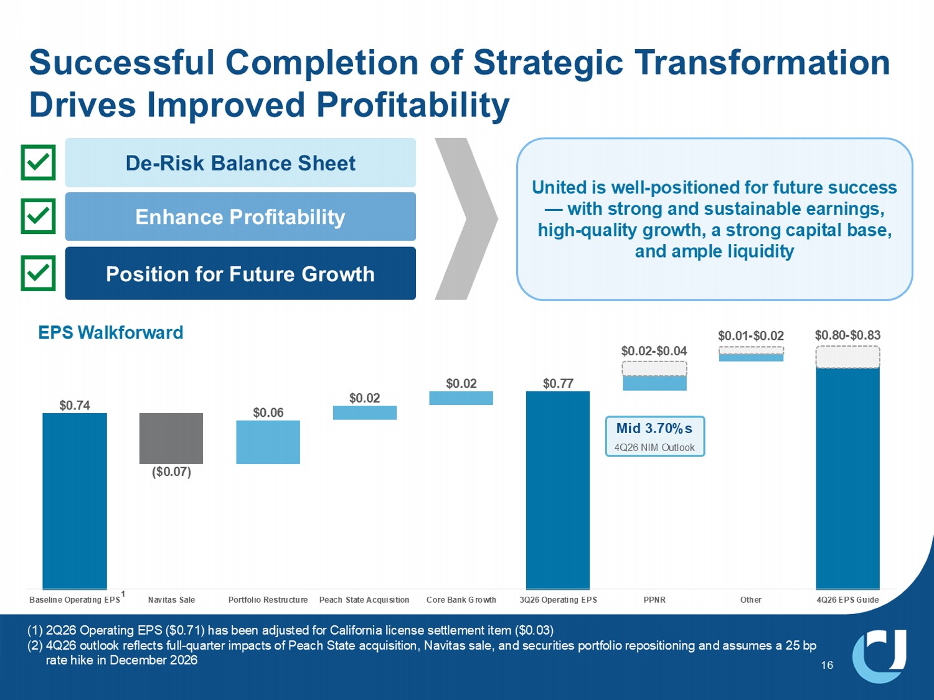
Successful Completion of Strategic Transformation Drives Improved Profitability 16 (1) 2Q26 Operating EPS ($0.71) has been adjusted for California license settlement item ($0.03) (2) 4Q26 outlook reflects full - quarter impacts of Peach State acquisition, Navitas sale, and securities portfolio repositioning and assumes a 25 bp rate hike in December 2026 $0.74 ($0.07) $0.06 $0.02 $0.02 $0.77 Baseline Operating EPS Navitas Sale Portfolio Restructure Peach State Acquisition Core Bank Growth 3Q26 Operating EPS PPNR Other 4Q26 EPS Guide 1 EPS Walkforward $0.80 - $0.83 $0.01 - $0.02 Mid 3.70%s 4Q26 NIM Outlook De - Risk Balance Sheet Enhance Profitability Position for Future Growth United is well - positioned for future success — with strong and sustainable earnings, high - quality growth, a strong capital base, and ample liquidity $0.02 - $0.04


0HPEHU)',& 8QLWHG&RPPXQLW\%DQN_ XFELFRP 3Q26 INVESTOR PRESENTATION Exhibits


&XOWXUDO)RXQGDWLRQVRI8QLWHG&RPPXQLW\ 18 Our Story Founded 76 years ago as Union County Bank, United Community has stayed true to its roots by prioritizing service. We continue to embrace our small - town, personal touch while offering a comprehensive range of personal and business banking services. Team We play to win together as a team Truth We want to see things as they are, not as we want them to be Trust We trust in people Caring We treat our customers, and each other, the way that we would want to be treated %HVW%DQNWR:RUN ) RU LQ IRUWKH WK FRQVHFXWLYH\HDU Most Awarded Bank in the Southeast Region for Retail Banking Customer Satisfaction Best Bank Awards for outstanding small business banking in 2026 To Be a Legendary Bank Our Vision Our Core Values Our Accolades Our Purpose 7R%XLOG&RPPXQLWLHV

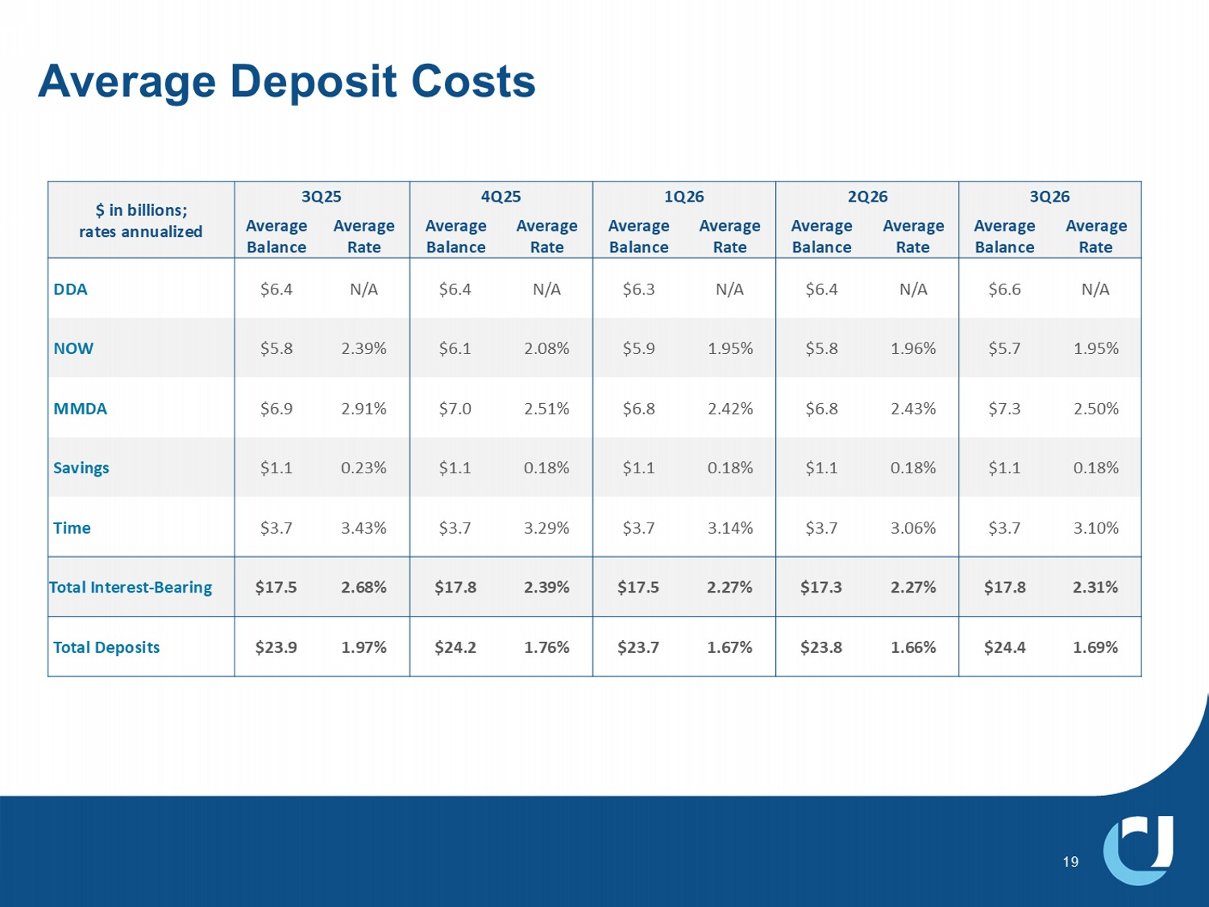
Average Deposit Costs 19 3Q26 2Q26 1Q26 4Q25 3Q25 $ in billions; rates annualized Average Rate Average Balance Average Rate Average Balance Average Rate Average Balance Average Rate Average Balance Average Rate Average Balance N/A $6.6 N/A $6.4 N/A $6.3 N/A $6.4 N/A $6.4 DDA 1.95% $5.7 1.96% $5.8 1.95% $5.9 2.08% $6.1 2.39% $5.8 NOW 2.50% $7.3 2.43% $6.8 2.42% $6.8 2.51% $7.0 2.91% $6.9 MMDA 0.18% $1.1 0.18% $1.1 0.18% $1.1 0.18% $1.1 0.23% $1.1 Savings 3.10% $3.7 3.06% $3.7 3.14% $3.7 3.29% $3.7 3.43% $3.7 Time 2.31% $17.8 2.27% $17.3 2.27% $17.5 2.39% $17.8 2.68% $17.5 Total Interest - Bearing 1.69% $24.4 1.66% $23.8 1.67% $23.7 1.76% $24.2 1.97% $23.9 Total Deposits

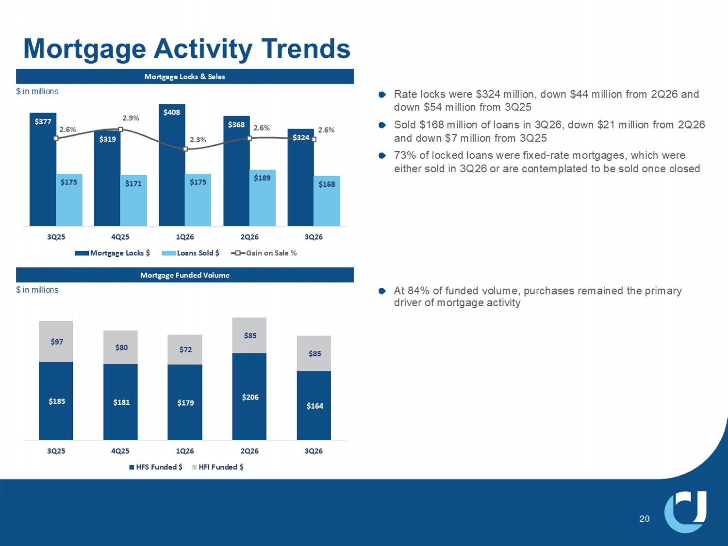
5DWHORFNVZHUH PLOOLRQGRZQ PLOOLRQIURP 4 DQG GRZQ PLOOLRQIURP 4 6ROG PLOOLRQRIORDQVLQ 4 GRZQ PLOOLRQIURP 4 DQGGRZQ PLOOLRQIURP 4 RIORFNHGORDQVZHUHIL[HG UDWHPRUWJDJHVZKLFKZHUH HLWKHUVROGLQ 4 RUDUHFRQWHPSODWHGWREHVROGRQFHFORVHG Mortgage Locks & Sales Mortgage Funded Volume Mortgage Activity Trends $377 $319 $408 $368 ϯϮϰ $175 $171 $175 $189 $168 2.6% 2.9% Ϯϯ й 2.6% 2.6% 3Q25 4Q25 1Q26 2Q26 3Q26 Mortgage Locks $ Loans Sold $ Gain on Sale % $185 $181 $179 $206 $164 ϵ; $80 $72 $85 $85 3Q25 4Q25 1Q26 2Q26 3Q26 HFS Funded $ HFI Funded $ 20 At 84% of funded volume, purchases remained the primary driver of mortgage activity $ in millions LQPLOOLRQV

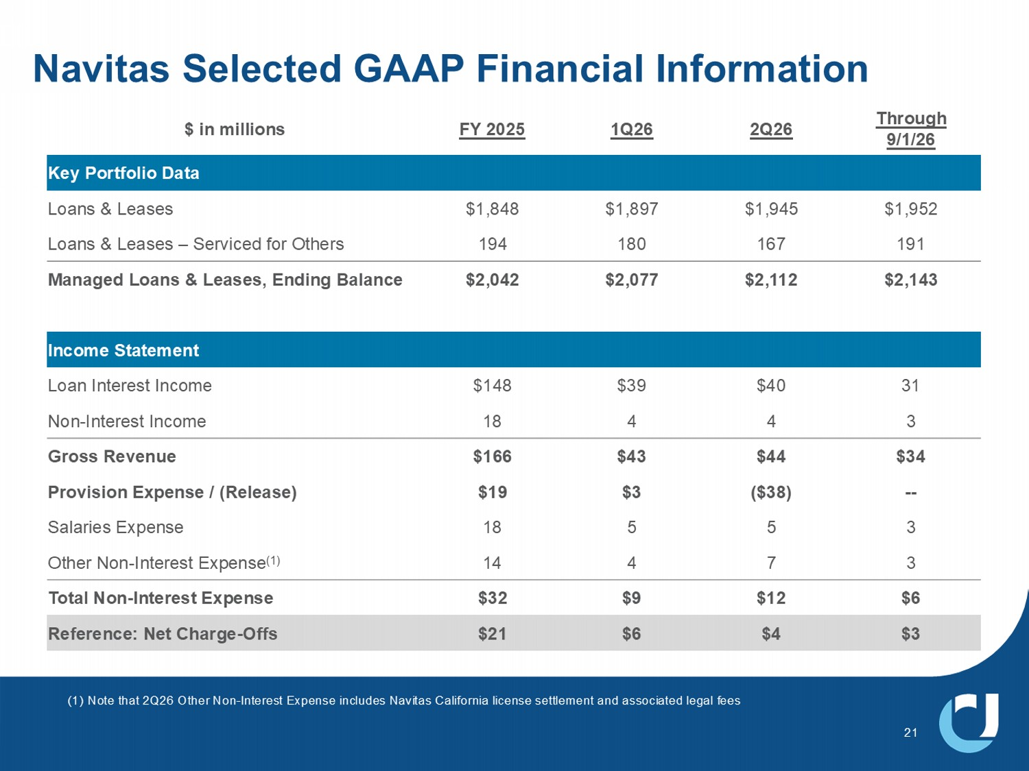
Navitas Selected GAAP Financial Information 21 1RWHWKDW 4 2WKHU1RQ ,QWHUHVW([SHQVHLQFOXGHV1DYLWDV&DOLIRUQLDOLFHQVHVHWWOHPHQWDQGDVVRFLDWHGOHJDOIHHV Through 9/1/26 2Q26 1Q26 FY 2025 $ in millions Key Portfolio Data $1,952 $1,945 $1,897 $1,848 Loans & Leases 191 167 180 194 Loans & Leases – Serviced for Others $2,143 $2,112 $2,077 $2,042 Managed Loans & Leases, Ending Balance Income Statement 31 $40 $39 $148 Loan Interest Income 3 4 4 18 Non - Interest Income $34 $44 $43 $166 Gross Revenue -- ($38) $3 $19 Provision Expense / (Release) 3 5 5 18 Salaries Expense 3 7 4 14 Other Non - Interest Expense (1) $6 $12 $9 $32 Total Non - Interest Expense $3 $4 $6 $21 Reference: Net Charge - Offs

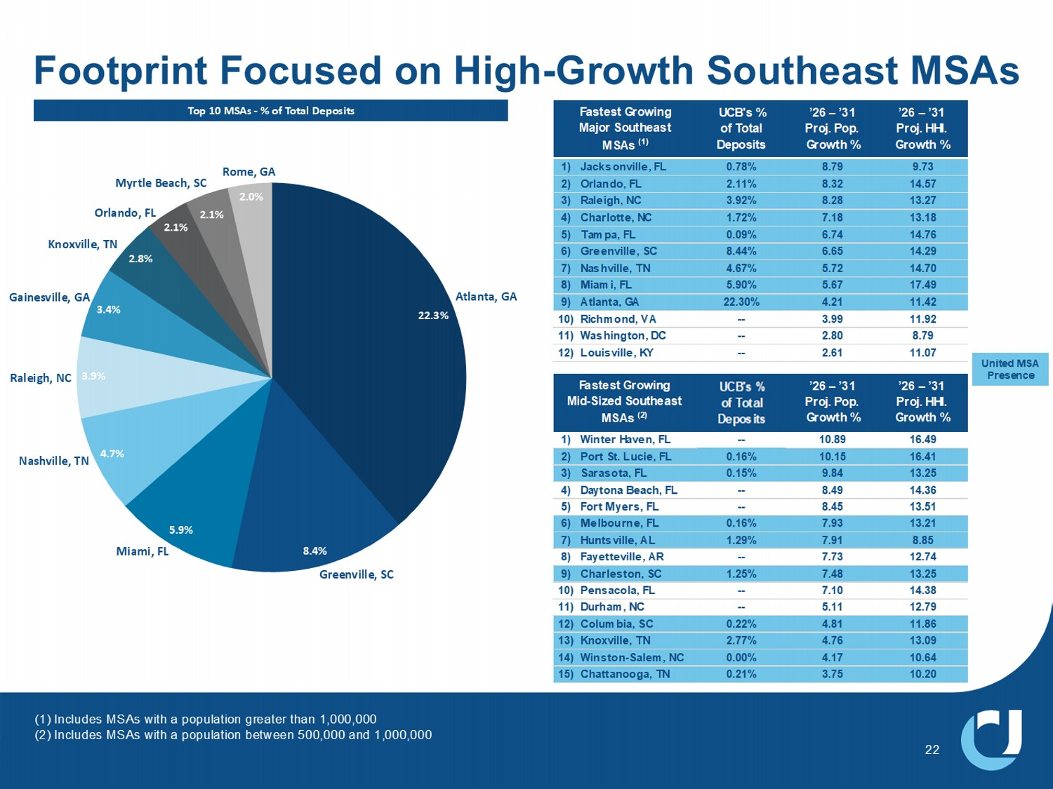
(1) Includes MSAs with a population greater than 1,000,000 (2) Includes MSAs with a population between 500,000 and 1,000,000 Footprint Focused on High - Growth Southeast MSAs 22 22.3% ϴϰ й 5.9% 4.7% 3.9% 3.4% 2.8% 2.1% 2.1% Ϯ й Atlanta, GA Greenville, SC Nashville, TN Miami, FL Raleigh, NC Gainesville, GA Knoxville, TN KƌůĂŶĚŽ͕&> Rome, GA Myrtle Beach, SC Top 10 MSAs - % of Total Deposits UCB's % of Total Deposits ’26 – ’31 Proj. Pop. Growth % ’26 – ’31 Proj. HHI. Growth % 1) Jacksonville, FL 0.78% 8.79 9.73 2) Orlando, FL 2.11% 8.32 14.57 3) Raleigh, NC 3.92% 8.28 13.27 4) Charlotte, NC 1.72% 7.18 13.18 5) Tampa, FL 0.09% 6.74 14.76 6) Greenville, SC 8.44% 6.65 14.29 7) Nashville, TN 4.67% 5.72 14.70 8) Miami, FL 5.90% 5.67 17.49 9) Atlanta, GA 22.30% 4.21 11.42 10) Richmond, VA -- 3.99 11.92 11) Washington, DC -- 2.80 8.79 12) Louisville, KY -- 2.61 11.07 Fastest Growing Major Southeast MSAs (1) United MSA Presence UCBI's % of Total Deposits ’26 – ’31 Proj. Pop. Growth % ’26 – ’31 Proj. HHI. Growth % 1) Winter Haven, FL -- 10.89 16.49 2) Port St. Lucie, FL 0.16% 10.15 16.41 3) Sarasota, FL 0.15% 9.84 13.25 4) Daytona Beach, FL -- 8.49 14.36 5) Fort Myers, FL -- 8.45 13.51 6) Melbourne, FL 0.16% 7.93 13.21 7) Huntsville, AL 1.29% 7.91 8.85 8) Fayetteville, AR -- 7.73 12.74 9) Charleston, SC 1.25% 7.48 13.25 10) Pensacola, FL -- 7.10 14.38 11) Durham, NC -- 5.11 12.79 12) Columbia, SC 0.22% 4.81 11.86 13) Knoxville, TN 2.77% 4.76 13.09 14) Winston-Salem, NC 0.00% 4.17 10.64 15) Chattanooga, TN 0.21% 3.75 10.20 Fastest Growing Mid-Sized Southeast MSAs (2)

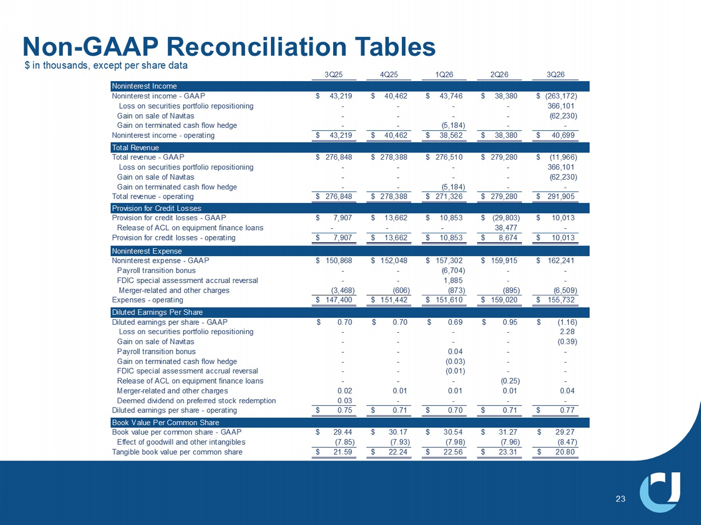
Non - GAAP Reconciliation Tables 23 3Q25 4Q25 1Q26 2Q26 3Q26 Noninterest Income Noninterest income - GAAP 43,219$ 40,462$ 43,746$ 38,380$ (263,172)$ Loss on securities portfolio repositioning - - - - 366,101 Gain on sale of Navitas - - - - (62,230) Gain on terminated cash flow hedge - - (5,184) - - Noninterest income - operating 43,219$ 40,462$ 38,562$ 38,380$ 40,699$ Total Revenue Total revenue - GAAP 276,848$ 278,388$ 276,510$ 279,280$ (11,966)$ Loss on securities portfolio repositioning - - - - 366,101 Gain on sale of Navitas - - - - (62,230) Gain on terminated cash flow hedge - - (5,184) - - Total revenue - operating 276,848$ 278,388$ 271,326$ 279,280$ 291,905$ Provision for Credit Losses Provision for credit losses - GAAP 7,907$ 13,662$ 10,853$ (29,803)$ 10,013$ Release of ACL on equipment finance loans - - - 38,477 - Provision for credit losses - operating 7,907$ 13,662$ 10,853$ 8,674$ 10,013$ Noninterest Expense Noninterest expense - GAAP 150,868$ 152,048$ 157,302$ 159,915$ 162,241$ Payroll transition bonus - - (6,704) - - FDIC special assessment accrual reversal - - 1,885 - - Merger-related and other charges (3,468) (606) (873) (895) (6,509) Expenses - operating 147,400$ 151,442$ 151,610$ 159,020$ 155,732$ Diluted Earnings Per Share Diluted earnings per share - GAAP 0.70$ 0.70$ 0.69$ 0.95$ (1.16)$ Loss on securities portfolio repositioning - - - - 2.28 Gain on sale of Navitas - - - - (0.39) Payroll transition bonus - - 0.04 - - Gain on terminated cash flow hedge - - (0.03) - - FDIC special assessment accrual reversal - - (0.01) - - Release of ACL on equipment finance loans - - - (0.25) - Merger-related and other charges 0.02 0.01 0.01 0.01 0.04 Deemed dividend on preferred stock redemption 0.03 - - - - Diluted earnings per share - operating 0.75$ 0.71$ 0.70$ 0.71$ 0.77$ Book Value Per Common Share Book value per common share - GAAP 29.44$ 30.17$ 30.54$ 31.27$ 29.27$ Effect of goodwill and other intangibles (7.85) (7.93) (7.98) (7.96) (8.47) Tangible book value per common share 21.59$ 22.24$ 22.56$ 23.31$ 20.80$ $ in thousands, except per share data

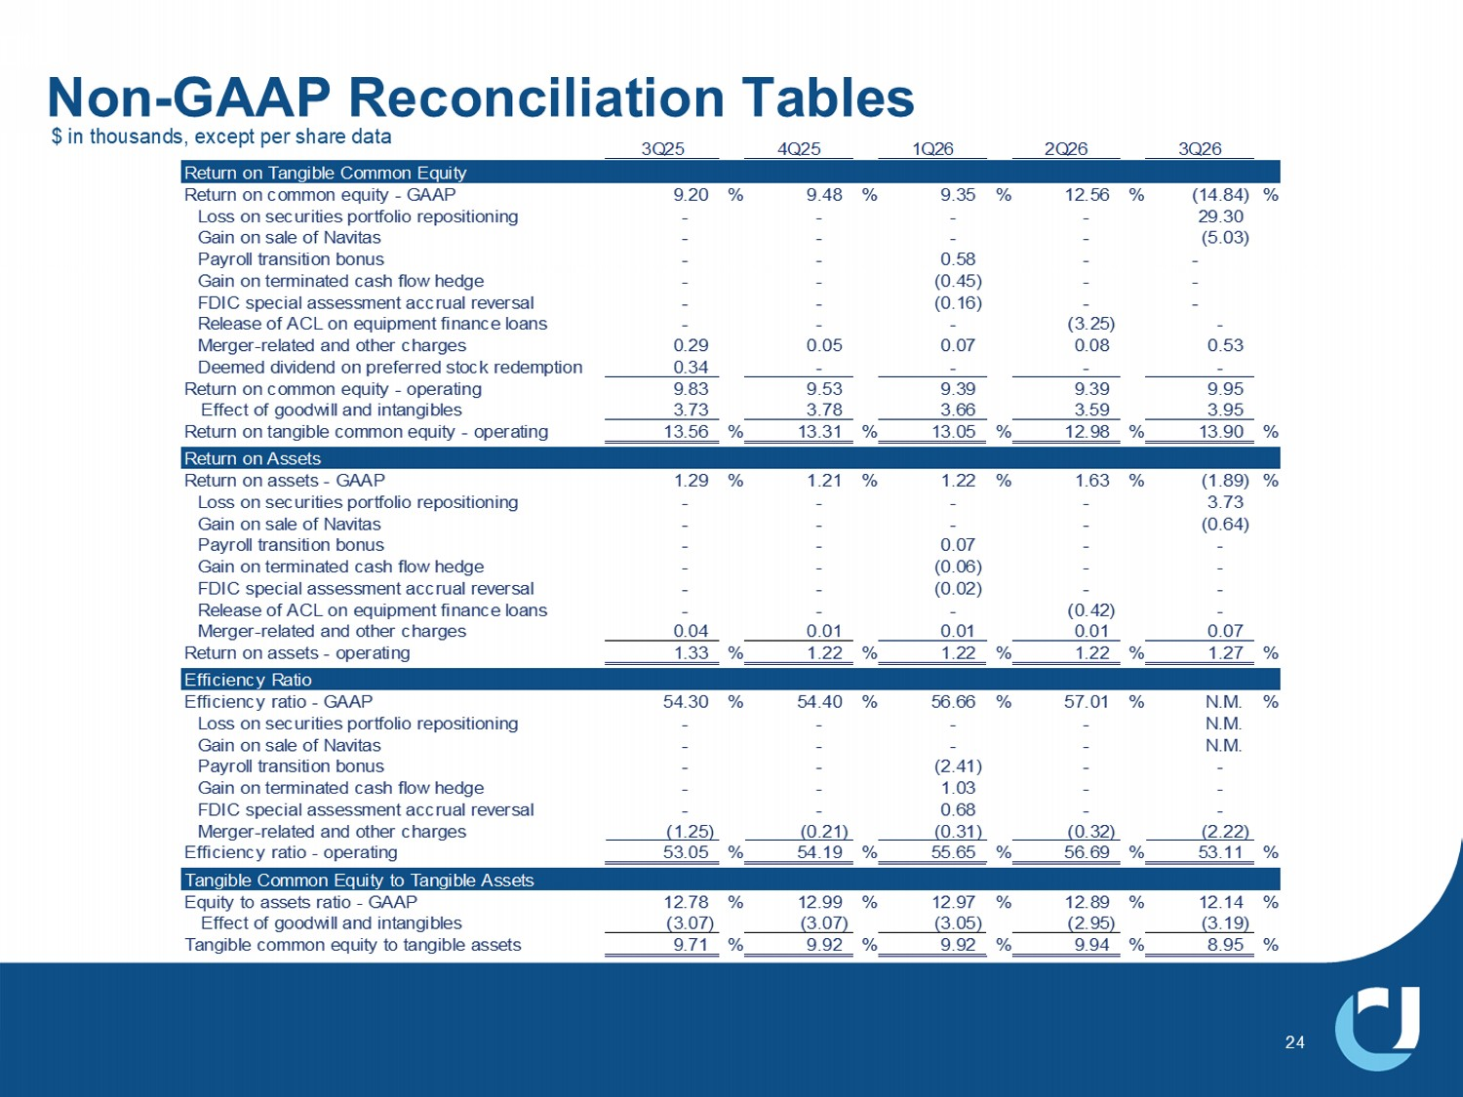
1RQ *$$35HFRQFLOLDWLRQ7DEOHV 24 3Q25 4Q25 1Q26 2Q26 3Q26 Return on Tangible Common Equity Return on common equity - GAAP 9.20 % 9.48 % 9.35 % 12.56 % (14.84) % Loss on securities portfolio repositioning - - - - 29.30 Gain on sale of Navitas - - - - (5.03) Payroll transition bonus - - 0.58 - - Gain on terminated cash flow hedge - - (0.45) - - FDIC special assessment accrual reversal - - (0.16) - - Release of ACL on equipment finance loans - - - (3.25) - Merger-related and other charges 0.29 0.05 0.07 0.08 0.53 Deemed dividend on preferred stock redemption 0.34 - - - - Return on common equity - operating 9.83 9.53 9.39 9.39 9.95 Effect of goodwill and intangibles 3.73 3.78 3.66 3.59 3.95 Return on tangible common equity - operating 13.56 % 13.31 % 13.05 % 12.98 % 13.90 % Return on Assets Return on assets - GAAP 1.29 % 1.21 % 1.22 % 1.63 % (1.89) % Loss on securities portfolio repositioning - - - - 3.73 Gain on sale of Navitas - - - - (0.64) Payroll transition bonus - - 0.07 - - Gain on terminated cash flow hedge - - (0.06) - - FDIC special assessment accrual reversal - - (0.02) - - Release of ACL on equipment finance loans - - - (0.42) - Merger-related and other charges 0.04 0.01 0.01 0.01 0.07 Return on assets - operating 1.33 % 1.22 % 1.22 % 1.22 % 1.27 % Efficiency Ratio Efficiency ratio - GAAP 54.30 % 54.40 % 56.66 % 57.01 % N.M. % Loss on securities portfolio repositioning - - - - N.M. Gain on sale of Navitas - - - - N.M. Payroll transition bonus - - (2.41) - - Gain on terminated cash flow hedge - - 1.03 - - FDIC special assessment accrual reversal - - 0.68 - - Merger-related and other charges (1.25) (0.21) (0.31) (0.32) (2.22) Efficiency ratio - operating 53.05 % 54.19 % 55.65 % 56.69 % 53.11 % Tangible Common Equity to Tangible Assets Equity to assets ratio - GAAP 12.78 % 12.99 % 12.97 % 12.89 % 12.14 % Effect of goodwill and intangibles (3.07) (3.07) (3.05) (2.95) (3.19) Tangible common equity to tangible assets 9.71 % 9.92 % 9.92 % 9.94 % 8.95 % $ in thousands, except per share data

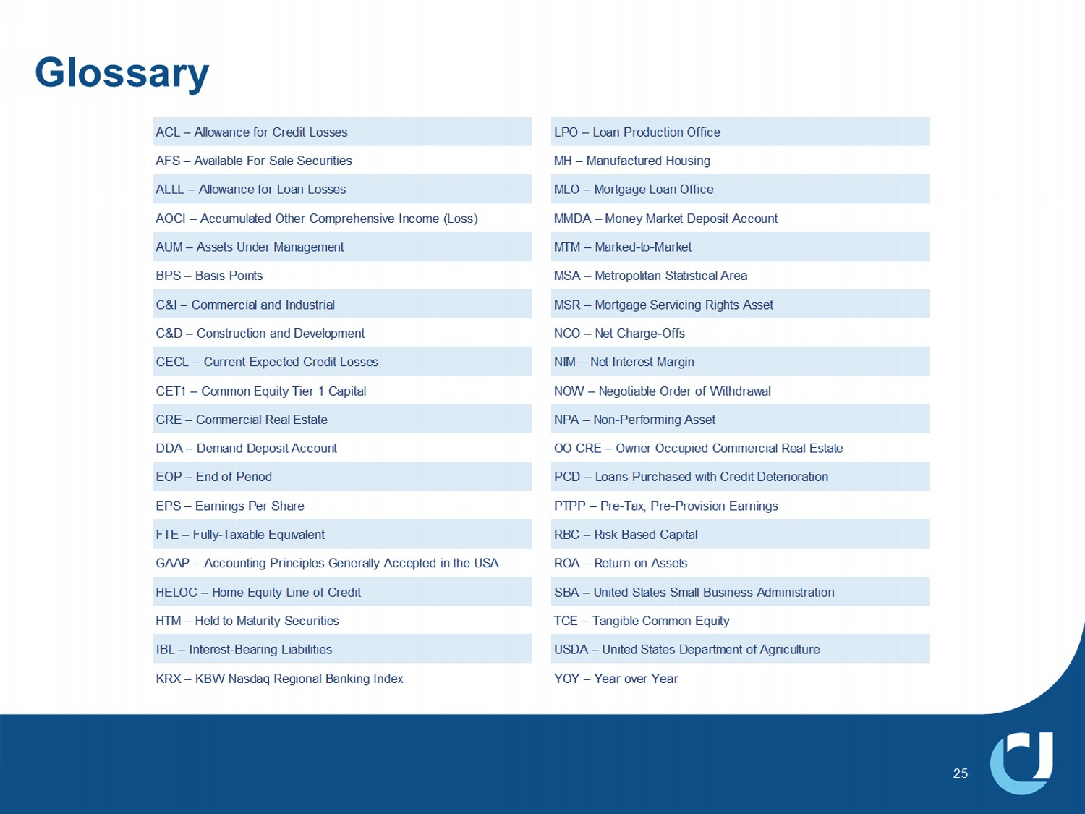
Glossary ACL – Allowance for Credit Losses LPO – Loan Production Office AFS – Available For Sale Securities MH – Manufactured Housing ALLL – Allowance for Loan Losses MLO – Mortgage Loan Office AOCI – Accumulated Other Comprehensive Income (Loss) MMDA – Money Market Deposit Account AUM – Assets Under Management MTM – Marked-to-Market BPS – Basis Points MSA – Metropolitan Statistical Area C&I – Commercial and Industrial MSR – Mortgage Servicing Rights Asset C&D – Construction and Development NCO – Net Charge-Offs CECL – Current Expected Credit Losses NIM – Net Interest Margin CET1 – Common Equity Tier 1 Capital NOW – Negotiable Order of Withdrawal CRE – Commercial Real Estate NPA – Non-Performing Asset DDA – Demand Deposit Account OO CRE – Owner Occupied Commercial Real Estate EOP – End of Period PCD – Loans Purchased with Credit Deterioration EPS – Earnings Per Share PTPP – Pre-Tax, Pre-Provision Earnings FTE – Fully-Taxable Equivalent RBC – Risk Based Capital GAAP – Accounting Principles Generally Accepted in the USA ROA – Return on Assets HELOC – Home Equity Line of Credit SBA – United States Small Business Administration HTM – Held to Maturity Securities TCE – Tangible Common Equity IBL – Interest-Bearing Liabilities USDA – United States Department of Agriculture KRX – KBW Nasdaq Regional Banking Index YOY – Year over Year 25

